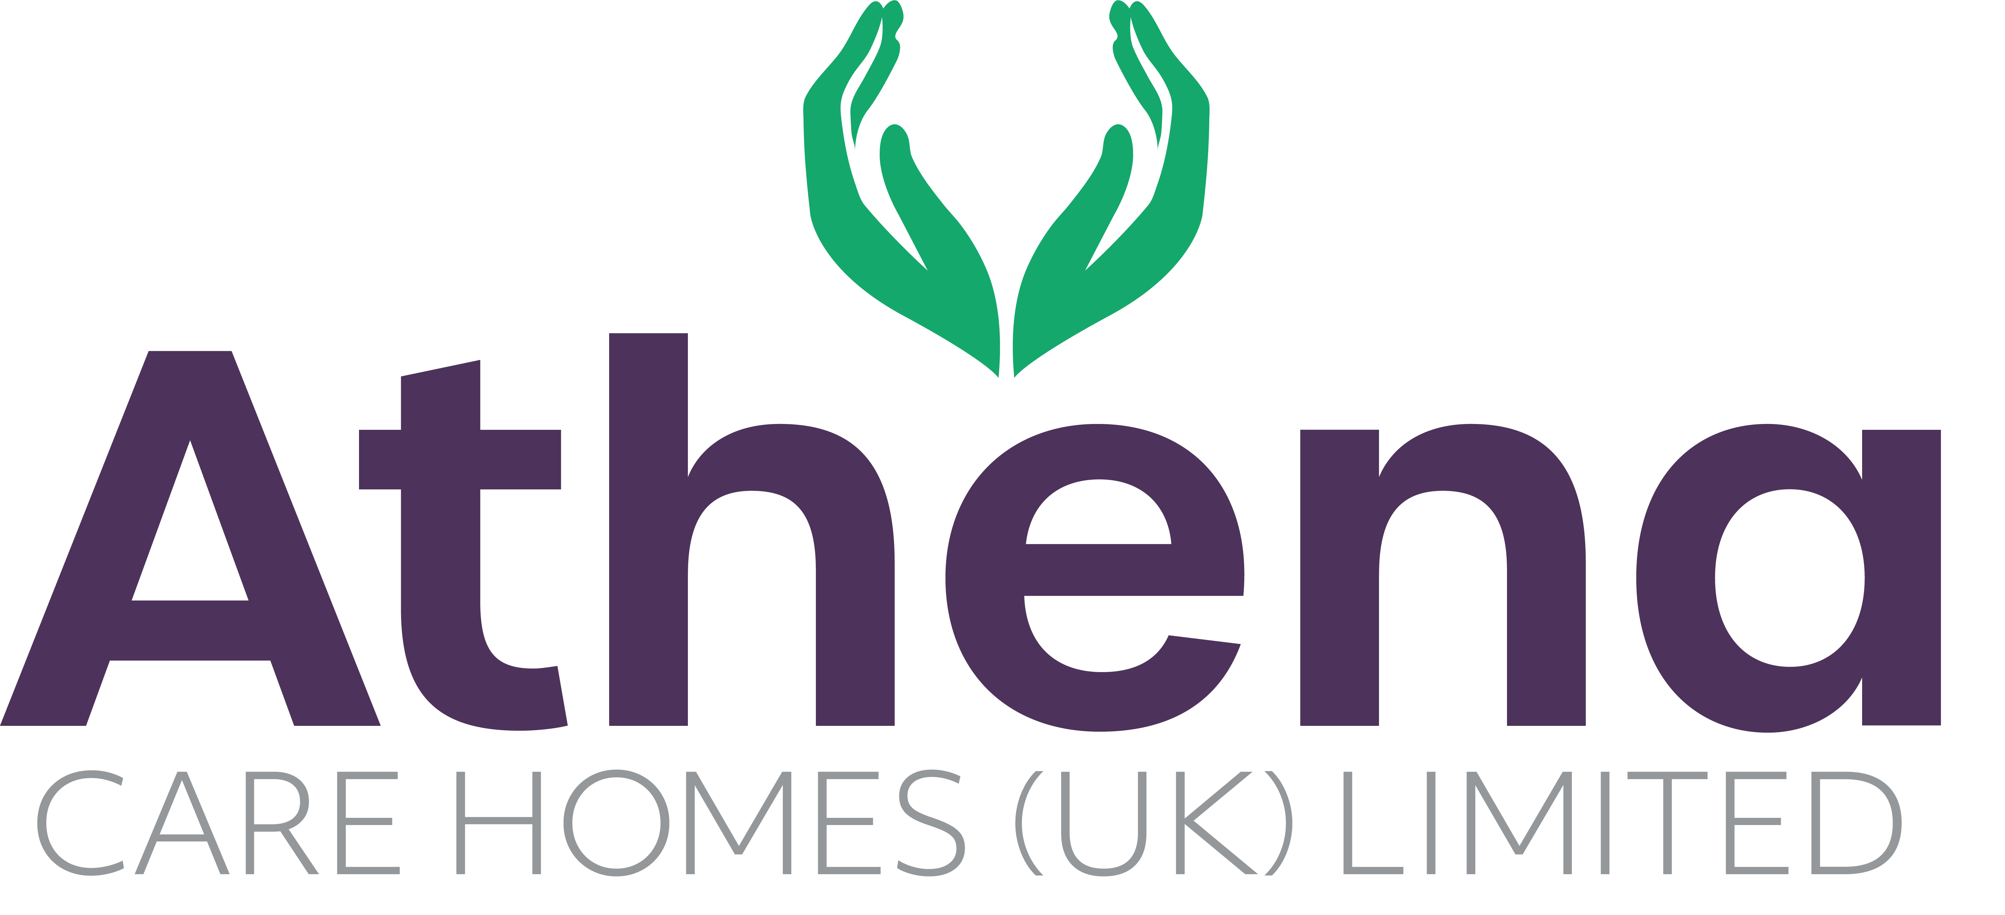

JOB DESCRIPTION

**Admin Manager**

|  |
| --- |
| **JOB SUMMARY** |

Reporting to the Home Manager, the Admin Manager is responsible for all the financial and administrative duties within the home.

The Admin Manager will manage and lead the administration team to ensure the smooth and efficient management of the administrative duties within the home and that customer service is provided to the highest standards.

|  |
| --- |
| **JOB SPECIFIC RESPONSIBILITIES** |

**Administration**

* Ensure that the all aspects of the administration function are delivered at a high standard.
* Manage the Business Administrator and the Admin Assistant, provide training and guidance along with completing supervisions and appraisals as per schedule.
* Ensure that all financial arrangements comply with Company policies and procedures.
* Work closely with the Customer Relations Manager to promote the home in the local community and support in the management if resident and family enquires in the absence of the CRM.
* Ensure that all admission documentation is accurate and is entered in a timely manner on to the relevant information system. Continue to maintain records and update central office with any changes.
* Ensure that all residents have the correct terms and conditions in place. Liaising with local authorities and CCGs to ensure contracts are in place as necessary.
* Updating the relevant information system promptly with admission and discharges and using this information to produce the Daily Report for Central Support by the designated cut off time.
* Record all deposits and withdrawals for personal allowance. Ensuring that all withdrawals are receipted and accounts to not become overdrawn. Monthly reconciliations of personal allowance to be completed and filed.
* Report all debt to the Home Manager on a monthly basis. Review the debtor’s list from the system on a monthly basis and make calls to recover the debt and send appropriate letters to clients with outstanding debt.
* Record all monies that come into the home and ensure that banking is completed weekly.
* Maintain the petty cash, recording all disbursements and actioning reclaims to maintain the float, producing a monthly report for submission to Central Support Office.
* Assist Central Support with credit control
* Ensure that all purchase orders are completed accurately and authorized appropriately.
* Maintain records of all orders and invoices submitted for reconciliation and payment to Central Support Office to allow prompt and accurate responses to enquiries.
* Keep records of Agency orders.
* Build positive relationships with all stakeholders including CQC, Local Authorities, CCG’s, Social Services etc.
* Provide the highest level of Customer Service at all times to existing and prospective clients to support them in having an enjoyable and positive experience with Athena Care.

**HR**

* Check all new Team Member files to ensure they are compliant and have the required, references, DBS, Right to Work checks and other paperwork in place prior to commencement and that this is all recorded correctly on People Planner.
* Work closely with the HR Team and Resourcing Manager to ensure the safe recruitment and onboarding of team members. Keeping establishment hours up to date and notifying the Home Manager of vacancies.
* Maintain People Planner system, completing daily reconciliations, updating starters and leavers, recording annual leave and absences.
* Complete Team Member contractual changes as required and submit to Central Support
* Oversee the payroll; ensuring that relevant documents are obtained and forwarded to central support for events such as maternity/paternity leave, sickness and payroll enquiries.
* Ensure that all information of confidential nature is not divulged to third parties.
* Completing daily, weekly, monthly tasks as detailed on checklist.
* Manage archiving process of personal records.
* Work in conjunction with the Learning & Development Team to support in producing reports, coordinating training sessions, recording Team Member attendance and being responsible for maintaining the Hippo system to ensure compliance levels are at a minimum of 95%.
* Responsible for ensuring confidential information is kept secure at all times and consistently remain compliant with the General Data Protection Regulation policy.

|  |
| --- |
| **PERSON SPECIFICATION** |

|  |  |
| --- | --- |
|  | Essential Criteria |
| Qualifications/Education | * GCSE’s grade C/4 or above or equivalent in both English and Maths |
| Experience | * Minimum 2 years’ experience working within an Administrator position. * Experience with working in a team (desirable) * Experience of leading a Team * Experience with working in a care home (desirable) * Financial experience. * HR experience |
| **Skills/**  **Knowledge** | * Excellent written, non-verbal and verbal communication skills * Good Knowledge and competence in Microsoft Office applications and windows based operating environments * Excellent customer service skills |
| Personal Qualities | * Reliable, flexible and punctual * Able to adapt to change * Approachable and confident * Diplomatic * Enthusiastic * Influencing, listening and negotiating skills * Patient * Positive attitude * Self-motivator * Flexible approach to working hours - able to work outside of normal hours. * Ability to promote a professional image for the company at all times * Ability to travel to other homes where needed for training / support |

**This job description reflects the current main organizational priorities for the position. These priorities may develop and change in consultation with the post holder in line with needs and priorities of the business.**