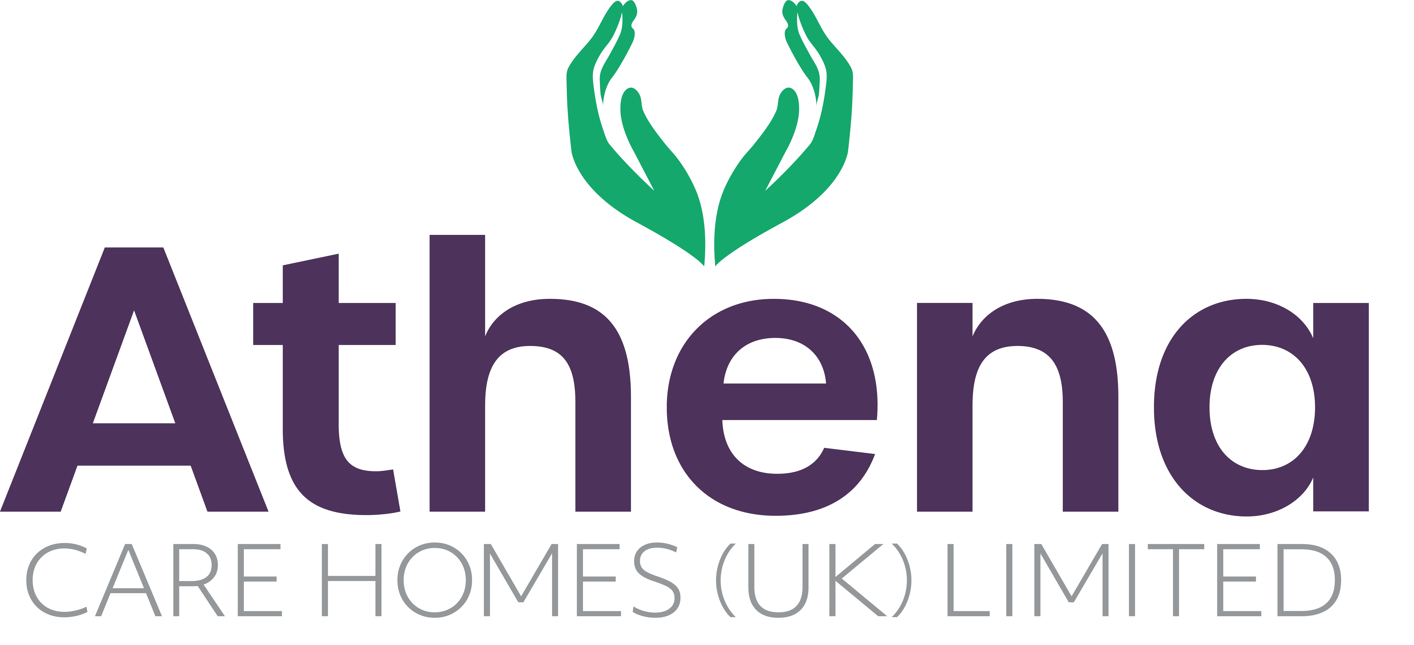

JOB DESCRIPTION

**Care Assistant**

|  |
| --- |
| **JOB SUMMARY** |

Reporting to the Team Leader / CCA / Registered Nurse, the Care Assistant is responsible for ensuring a high level of care is provided to our residents and meets the code of conduct and company procedures.

The Care Assistant will provide and ensure the highest standards of care are achieved in all areas of the home including person centered care, clinical care and dementia care.

|  |
| --- |
| **JOB SPECIFIC RESPONSIBILITIES** |

**Clinical Care and Support**

* Provide and assist your lead on shift with all aspects of care in the home.
* Deliver care in the home, to ensure continuous assessment, planning, implementation and evaluation of residents’ care.
* Assist your lead on shift with basic nursing care to residents.
* Provide high quality care to residents at all times paying attention to their specific and individual needs.
* Assist residents during meal times ensuring they receive meals that are suitable.
* Ensure that your lead on shift are made aware of any care issues within the home.
* Assist the care team in weighing the residents as and when required.
* Assist with and participate in all activities provided within the home to promote person centered care.
* Assist with ensuring care plans are regularly reviewed, updated and that they are appropriate to the residents needs and reflect the care being delivered.
* To actively engage with residents in conversation and meaningful occupation related to their lifestyle choices at a level and pace that values the individual and respects their dignity and communication differences.
* To respond in a timely way to residents who are distressed (calling out, calling for help, knocking or making noises that suggest the need for support) or seek assistance if you feel unable to respond appropriately.

**Health and Safety**

* Attend and complete all training and qualifications (statutory, mandatory and developmental).
* Ensure Senior Carers or RNs are informed of any incidents in the home.
* Ensure storage of medications are in line with company policies and procedures
* Ensure risk assessments are completed within the home and safe working practices are being followed.
* Ensure equipment and environment is safe within the home
* You will be required for this role to potentially liftheavy objects and operate lifting equipment (with training).

|  |
| --- |
| **PERSON SPECIFICATION** |

|  |  |
| --- | --- |
|  | Essential Criteria |
| Qualifications/Education | * QCF Diploma Level 2 / NVQ Level 2 in Health & Social Care (**Desirable**)   OR where no QCF/NVQ held:   * Willingness to work towards achievement of QCF Diploma Level 2 in Health & Social Care |
| Experience | * Working within a care home environment * Experience delivering high quality relationship centered care (**Desirable**) |
| **Skills/**  **Knowledge** | * Strong customer service skills * Excellent written, non-verbal and verbal communication skills * Knowledge of dementia (for care homes for people living with dementia) (**Desirable**) |
| Personal Qualities | * Reliable and punctual * Able to adapt to change * Approachable * Confident * Diplomatic * Enthusiastic * Flexible * Listening skills * Patient * Positive attitude * Self-motivator * Flexible approach to working hours - able to work on a shift basis * Ability to promote a professional image for the company at all times * Willing and able to travel to other homes where needed for training / support * Able to adapt to the Athena culture |

**This job description reflects the current main organisational priorities for the position. These priorities may develop and change in consultation with the post holder in line with needs and priorities of the business.**