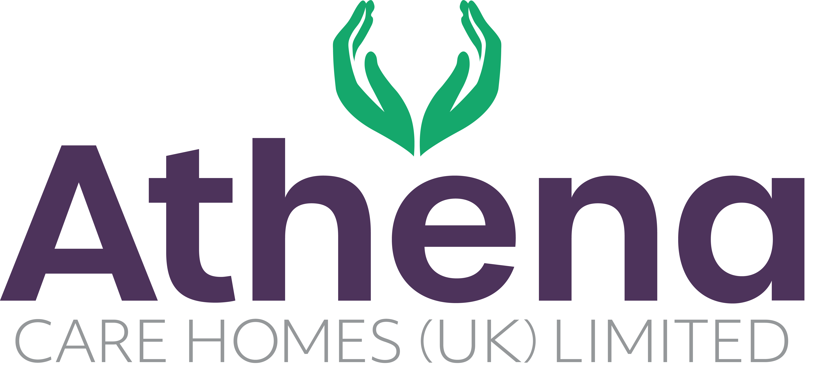

JOB DESCRIPTION
Clinical Care Lead

JOB SUMMARY

Reporting to the Deputy Manager, the Clinical Care Lead is responsible for ensuring a high level of clinical care and governance is provided to residents, meets all statutory and regulatory requirements and is aligned to codes of conduct and company procedures.

The Clinical Care Lead will lead the clinical team in providing strong clinical knowledge, leadership and management to ensure the highest standards are achieved in all areas of the home including relationship centred care, clinical care and dementia care.

JOB SPECIFIC RESPONSIBILITIES

Leadership and Management
- Overall responsibility for clinical care in the home.
- Deputise for the Deputy Manager during periods of absence
- Support with the recruitment and training of the clinical team; ensuring training targets are met and the team is competent in their roles.
- Manage rotas and ensure that the correct skill mix and number of team members are in the home on a continual basis.
- Lead, coach, support and inspire the clinical team to deliver outcomes for the home.
- Provide leadership to the clinical team to ensure they are aligned with the Athena vision and are operating from the Athena values.
- Initiate regular communication with colleagues, residents, relatives, and external stakeholders.
- Ensure that all regulatory and statutory requirements are met and company policies and procedures are adhered to.
- Ensure any requirements of a clinical perspective from internal and external audits are actioned within the timescales required.
- Ensure nurses are up to date with Prep in accordance with NMC guidance.
- Ensure that all medication administrators are competency assessed in line with Athena Policy.

Clinical Care
- Lead care delivery in the clinical community, to ensure continuous assessment, planning, implementation and evaluation of residents’ care.
- Overall responsibility for clinical compliance in the home in accordance with internal and external regulations and requirements.
- Ensure that an outstanding level of relationship centered care, dementia care and clinical care is being delivered within the home.
- Ensure care plans are regularly reviewed and audited and that they are appropriate to the residents needs and reflect the care being delivered.
- Responsible for pre-admission assessments and resident reviews.
- Ensure medication is ordered in line with company policies and procedures.
- Ensure medication audits are completed in line with company policies.
- Proactively research current and future clinical practices to ensure Athena are leading the way with clinical care delivery.
- Ensure clinical aspects of induction for new starters are completed and the team is fully competent and compliant in their clinical role.
- To actively engage with residents in conversation and meaningful occupation related to their lifestyle choices at a level and pace that values the individual and respects their dignity and communication differences.
- To respond in a timely way to residents who are distressed (calling out, calling for help, knocking or making noises that suggest the need for support) or seek assistance if you feel unable to respond appropriately.

Health and Safety
- Overall responsibility for Health & Safety within the clinical care team.
- Ensure Quality Team is informed of any incidents in the absence of the Home Manager.
- Ensure storage of medications are in line with company policies and procedures
- Ensure risk assessments are completed within the home and safe working practices are being followed.
- Ensure equipment and environment is safe within the home.

PERSON SPECIFICATION

 | Essential Criteria
Qualifications/Education | - RN/RGN Qualified or RMN with strong clinical experience  - Dementia Qualification for Dementia Care Homes
Experience | - Minimum of two years shift leadership and management in a care home  - Proven track record in a care home environment delivering quality care  - Proven track record leading, empowering, supporting and motivating a clinical team  - Experience delivering high quality relationship centered care (Desirable)
Skills/  Knowledge | - Strong leadership skills  - Excellent written, non-verbal and verbal communication skills  - Dementia Knowledge (for Dementia Care Homes)  - Knowledge of and competence in Microsoft Office applications and windows based operating environments
Personal Qualities | - Reliable and punctual  - Able to adapt to change  - Approachable  - Confident  - Diplomatic  - Enthusiastic  - Flexible  - Influencing skills  - Listening skills  - Negotiating skills  - Patient  - Positive attitude  - Self-motivator  - Flexible approach to working hours - able to work occasional outside of normal hours.  - Ability to promote a professional image for the company at all times  - Ability to travel to other homes where needed for training / support  - Able to adapt to the Athena culture

This job description reflects the current main organisational priorities for the position. These priorities may develop and change in consultation with the post holder in line with needs and priorities of the business.

