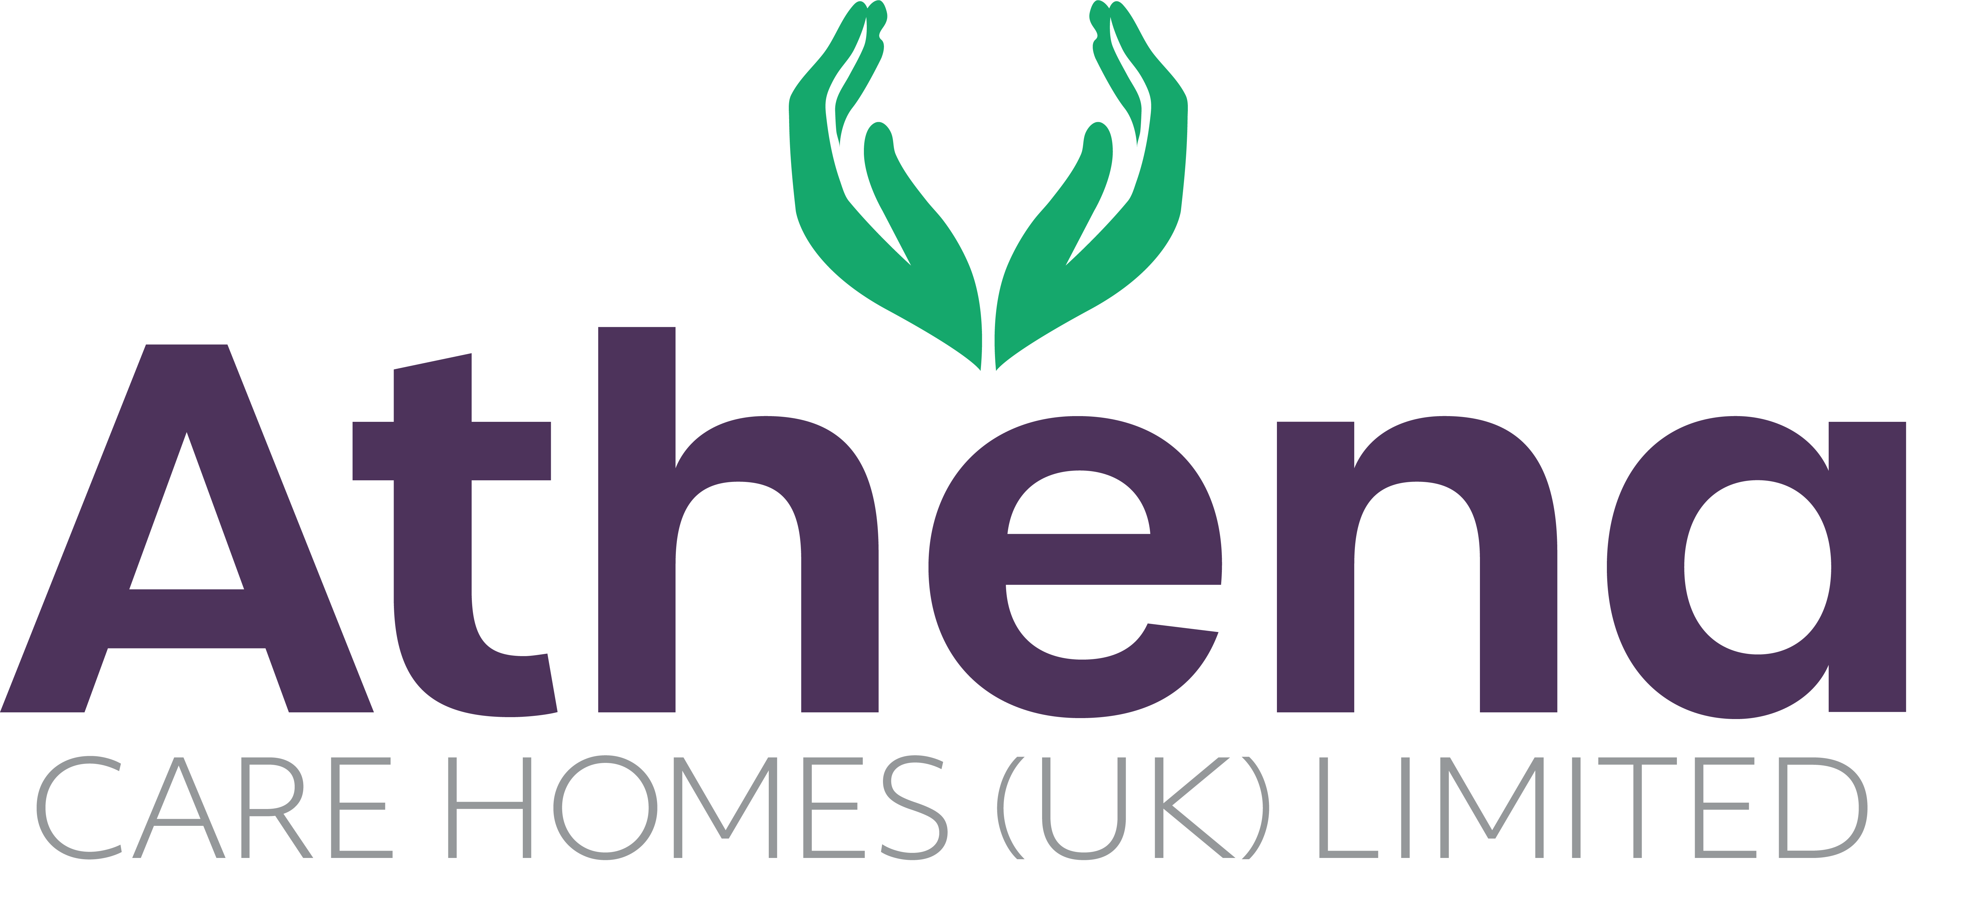

JOB DESCRIPTION
Cook

JOB SUMMARY

Reporting to the Head Chef, the Cook is responsible for ensuring a high quality of meal preparation is achieved within the home.

The Cook will assist the Kitchen team to work closely with the other service teams within the company to ensure the highest service standards are achieved.

JOB SPECIFIC RESPONSIBILITIES

Leadership and Management
- To assist the Head Chef to ensure all regulatory and statutory requirements are met and company policies and procedures are adhered to.
- To ensure day to day practice and performance is aligned with Athena’s vision and values at all times.
- To guide and lead the Kitchen Assistant posts when required to ensure their delivery of service is of the highest standard.

Hospitality Services
- To assist the Kitchen team to ensure the catering services and residential dining experience is of the highest standard and quality.
- To promote choice and dignity to the residents of the home with the services we provide.
- To assist the team to ensure the nutritional content of the meals provided cater for the dietary needs of all residents.
- To ensure reports relating to catering, are completed accurately and on time.
- To assist the kitchen team to ensure any requirements from internal and external audits are actioned within the timescales required.
- To liaise with residents to ensure they are happy with the food and beverages being delivered within the home
- To assist the team to ensure that requirements of the Food Safety Manual, Health and Safety Manual and Meal policies requirements are met.
- To actively engage with residents in conversation and meaningful occupation related to their lifestyle choices at a level and pace that values the individual and respects their dignity and communication differences.
- To respond in a timely way to residents who are distressed (calling out, calling for help, knocking or making noises that suggest the need for support) or seek assistance if you feel unable to respond appropriately.

Health and Safety
- Overall responsibility for Health & Safety within the catering services team.
- Ensure regulations and compliance are met and adhered to.
- Ensure cleanliness of kitchen and hygiene standards is achieved and maintained.
- Ensure equipment and environment is safe within the home.
- You will be required for this role to potentially lift heavy objects

PERSON SPECIFICATION

 | Essential Criteria
Qualifications/Education | - NVQ level 2 in Food Hygiene
Experience | - Minimum of one years catering background and  experience working within a kitchen environment  - Health & Safety knowledge in a busy working environment  - Proven track record in a care home environment delivering quality services (Desirable)
Skills/  Knowledge | - Strong leadership and management skills  - Excellent written, non-verbal and verbal communication skills  - Knowledge of and competence in Microsoft Office applications and Windows based operating environments – Excel, Word, Outlook, Explorer etc
Personal Qualities | - Reliable and punctual  - Able to adapt to change  - Approachable  - Confident  - Diplomatic  - Enthusiastic  - Flexible  - Influencing skills  - Listening skills  - Negotiating skills  - Patient  - Positive attitude  - Self-motivator  - Flexible approach to working hours - able to work occasionally outside of normal hours.  - Ability to promote a professional image for the company at all times  - Ability to travel to other homes where needed for training / support  - Able to adapt to the Athena culture

This job description reflects the current main organisational priorities for the position. These priorities may develop and change in consultation with the post holder in line with needs and priorities of the business.

