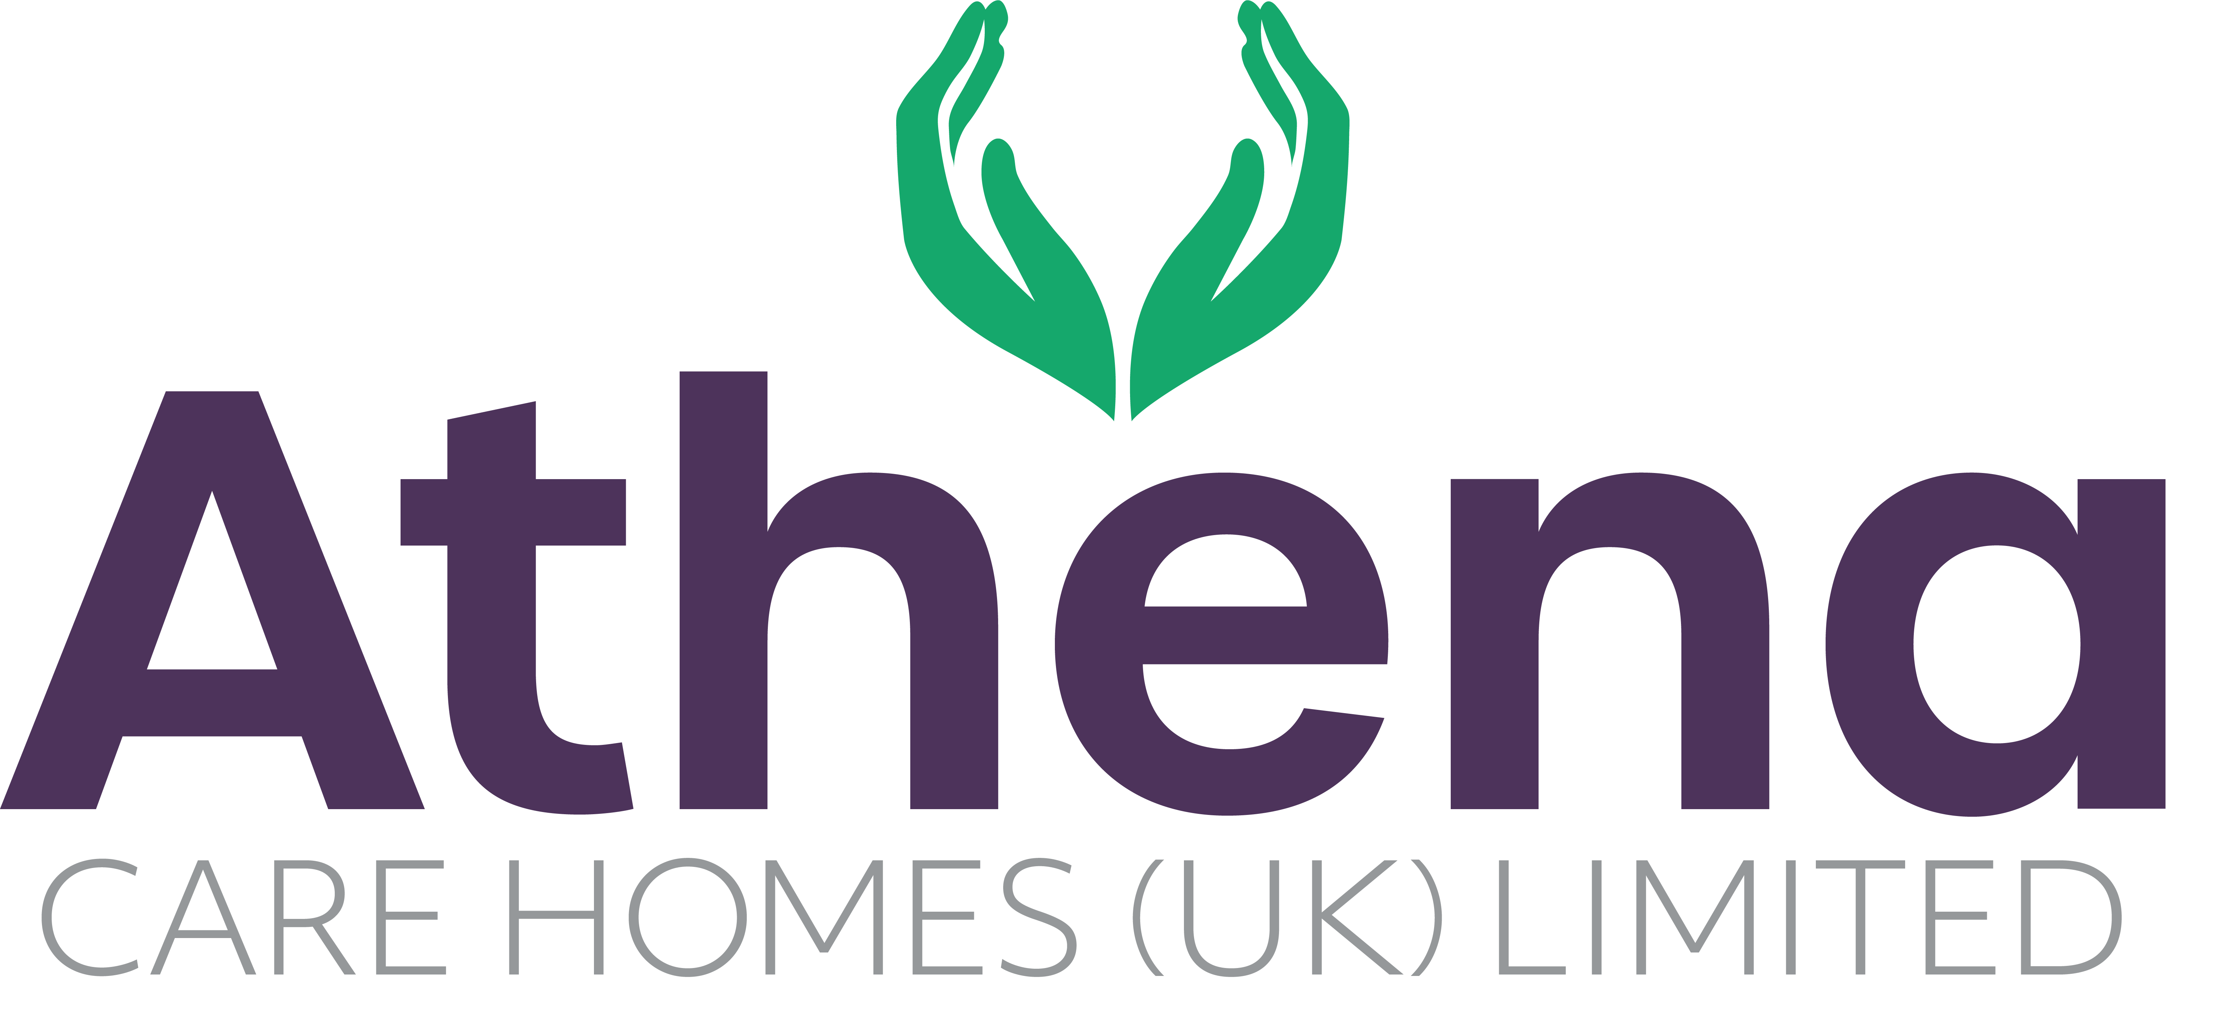

JOB DESCRIPTION
Deputy Manager

JOB SUMMARY

Reporting to the Home Manager, the Deputy Manager is responsible for ensuring a high level of clinical care and governance is provided to residents, meets all statutory and regulatory requirements and is aligned to codes of conduct and company procedures.

The Deputy Manager will lead the clinical team providing strong clinical knowledge, leadership and management to ensure the highest standards are achieved in all areas of the home including relationship centred care, clinical care and dementia care.

JOB SPECIFIC RESPONSIBILITIES

Clinical Care

- To motivate all team member within the Home
- To take part in the assessment, planning, implementation and evaluation of all care delivered to the clients.
- Assist as requested in all Athena’s Care Home audits.
- To assist the Home Manager with the selection of team member for employment within the Home.
- To continuously seek out ways of developing the service provided to the clients.
- To maintain excellent lines of communication with all outside agencies, including service purchasers.
- Manage resources effectively and efficiently.
- To manage team member by ensuring completion and adherence to team member rotas.
- To monitor all clinical standards on an on-going basis, and ensure corrective action is immediately taken to resolve any care deficits identified
- To maintain clinical involvement.
- To work with the Home Manager to ensure all training is up to date and on-going for all team members.
- To supervise the induction, support, and on-going training of all new team member.
- To promote high standards of record keeping.
- To ensure that all team member are aware of the importance of maintaining confidentiality with regards to clients and their records, and other sensitive information regarding Athena’s business.
- To counsel, advise and support all team member.
- To ensure all Health and Safety standards within the unit are monitored and any shortfalls identified and reported to the Home Manager.
- To be responsible for client safety within the unit ensuring risk assessments are completed as required and evaluated regularly.
- To adopt and promote high standards of multidisciplinary care input.
To ensure hospitality services team clean and maintain the unit to a high standard, in line with Company policy cleaning schedules.
- To attend multidisciplinary reviews as required.
- To monitor dietary intake for all clients and to liaise with the kitchen to ensure clients’ needs are met.
- To assist in any reviews of job descriptions and team appraisals as requested by the Home Manager.
- To promote and maintain advocacy for residents who may require this service.
- To provide professional advice to other trained nurses, whilst on call for the community.
- To support the Home Manager in all areas of management within the Home as required, including being ‘on call’ for the home at weekends on a rota basis.
- To support the Home Manager with all aspects of team training to ensure compliance is achieved.
- To support the Home Manager with all medication competencies within the home.
- To undertake any other reasonable task requested by superiors.
- Be able to carry out any other necessary duties as agreed with the line manager.

Health and Safety
- Overall responsibility for Health & Safety within the clinical care team.
- Ensure CEO is informed of any incidents in the absence of the Home Manager.
- Ensure storage of medications are in line with company policies and procedures
- Ensure risk assessments are completed within the home and safe working practices are being followed.
- Ensure equipment and environment is safe within the home.

PERSON SPECIFICATION

 | Essential Criteria
Qualifications/Education | - RN/RGN Qualified or RMN with strong clinical experience  - Dementia Qualification for Dementia Care Homes
Experience | - Minimum of two years shift leadership and management in a care home  - Proven track record in a care home environment delivering quality care  - Proven track record leading, empowering, supporting and motivating a clinical team  - Experience delivering high quality relationship centred care (Desirable)
Skills/  Knowledge | - Strong leadership skills  - Excellent written, non-verbal and verbal communication skills  - Dementia Knowledge (for Dementia Care Homes)  - Knowledge of and competence in Microsoft Office applications and windows based operating environments
Personal Qualities | - Reliable and punctual  - Able to adapt to change  - Approachable  - Confident  - Diplomatic  - Enthusiastic  - Flexible  - Influencing skills  - Listening skills  - Negotiating skills  - Patient  - Positive attitude  - Self-motivator  - Flexible approach to working hours - able to work occasional outside of normal hours.  - Ability to promote a professional image for the company at all times  - Ability to travel to other homes where needed for training / support  - Able to adapt to the Athena culture

This job description reflects the current main organisational priorities for the position. These priorities may develop and change in consultation with the post holder in line with needs and priorities of the business.

