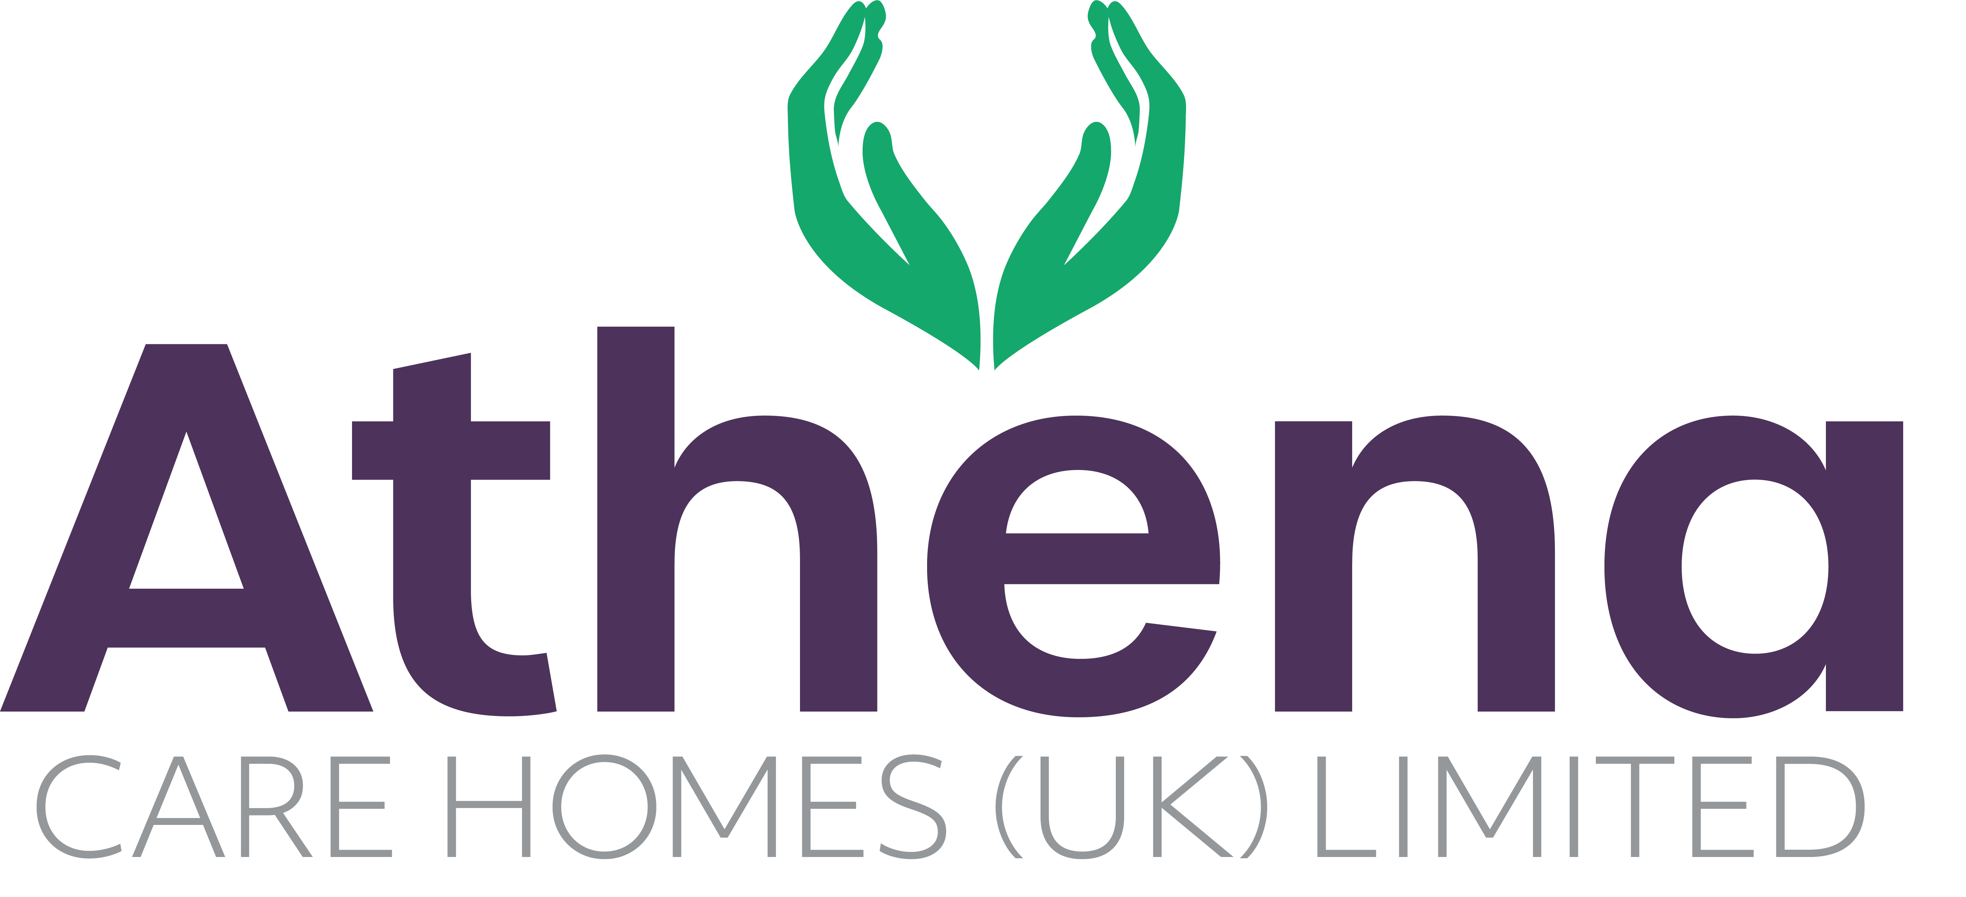

JOB DESCRIPTION

**Head Housekeeper**

|  |
| --- |
| **JOB SUMMARY** |

Reporting to the Home Manager, the Head Housekeeper is responsible for ensuring a high quality of housekeeping services throughout the home.

The Head Housekeeper will manage the laundry and all domestic services, areas working closely with their teams to provide strong leadership, management and inspiration to ensure the highest service standards are achieved and maintained at all times.

|  |
| --- |
| **JOB SPECIFIC RESPONSIBILITIES** |

**Head Housekeeping**

* Overall responsibility for support services within the home for laundry, domestic
* Support the Home Manager in the recruitment, Induction and training of the support service team; ensuring training targets are met and team is competent in their roles.
* Manage rotas and ensure correct team member levels are on shift at any time
* Support, lead, manage and inspire direct reports to deliver outcomes for the home.
* Ensure that all regulatory and statutory requirements are met and company policies and procedures are adhered to.
* Ensure reporting relating to laundry, domestic, are completed accurately and on time.
* Ensure that the Housekeeping budgets and expenditure targets are met whilst keeping adequate stock levels.
* Ensure any requirements from internal and external audits are actioned within the timescales required.
* Ensure the cleanliness of the home and residents’ personal laundry is to the highest standard
* Support the Home Manager to ensure that all team members are all aligned with the Athena vision and are operating from the Athena Charter.
* Liaise with suppliers to ensure maximum value and service are being provided
* To actively engage with residents in conversation and meaningful occupation related to their lifestyle choices at a level and pace that values the individual and respects their dignity and communication differences.
* To respond in a timely way to residents who are distressed (calling out, calling for help, knocking or making noises that suggest the need for support) or seek assistance if you feel unable to respond appropriately

**Health and Safety**

* Ensure all health and safety requirements are being met and attend training as required.
* Ensure regulations and compliance are met and adhered to.
* Ensure storage of medications are in line with company policies and procedures
* Ensure equipment and environment is safe within the home
* You will be required for this role to potentially liftheavy objects and/or use lifting equipment (with training)

|  |
| --- |
| **PERSON SPECIFICATION** |

|  |  |
| --- | --- |
|  | Essential Criteria |
| Qualifications/Education | * Management Qualification (**Desirable**) |
| Experience | * Minimum of two years hospitality background * Minimum of two years’ experience managing a team * Minimum of two years’ experience dealing with finance, budgets and targets. * Minimum of two years’ experience in a senior post within a hotel setting of 3* minimum * Experience working within a kitchen environment * Health & Safety knowledge in a busy working environment * Proven track record in a care home environment delivering quality services (**Desirable**) * Proven track record leading, empowering, supporting and motivating a service team |
| **Skills/**  **Knowledge** | * Strong leadership and management skills * Excellent written, non-verbal and verbal communication skills * Dementia Knowledge (for care homes with people living with dementia) (**Desirable**) * Knowledge of and competence in Microsoft Office applications and Windows based operating environments – especially Word, Excel, Outlook, Explorer and Powerpoint |
| Personal Qualities | * Reliable and punctual * Able to adapt to change * Approachable * Confident * Diplomatic * Enthusiastic * Flexible * Influencing skills * Listening skills * Negotiating skills * Patient * Positive attitude * Self-motivator * Flexible approach to working hours - able to work occasionally outside of normal hours. * Ability to promote a professional image for the company at all times * Ability to travel to other homes where needed for training / support * Able to adapt to the Athena culture |

**This job description reflects the current main organisational priorities for the position. These priorities may develop and change in consultation with the post holder in line with needs and priorities of the business.**