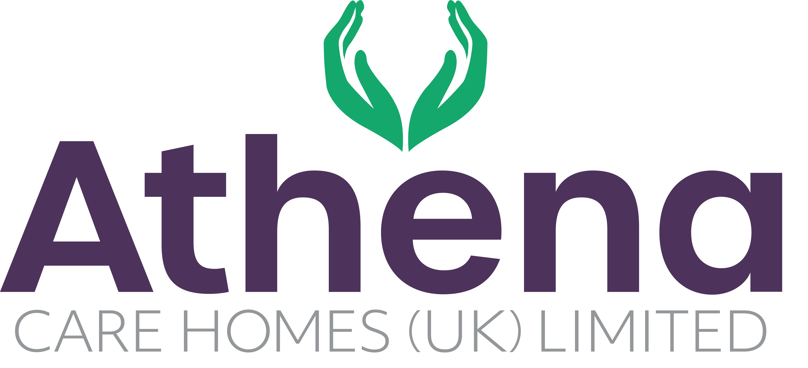

JOB DESCRIPTION

**Home Manager**

|  |
| --- |
| **JOB SUMMARY** |

To lead the care home team to deliver high quality relationship-centred care and services, for all residents ensuring compliance with internal and standards and achieving business targets.

|  |
| --- |
| **JOB SPECIFIC RESPONSIBILITIES** |

* Motivate, support, inspire and empower all team members in the home to deliver outcomes for the home and operate in alignment with the Athena vision and values.
* Manage the recruitment and training of the team; ensuring training targets are met and team are competent in their roles
* Manage rotas and ensure correct team member levels and skill mix within the home on a continual basis
* Lead all heads of department to ensure they meet our standards and aim to become ‘Outstanding’ in all aspects of the CQC framework.
* Manage the clinical supervision, appraisal and performance management of the team, supporting them to achieve their potential
* Ensure that the home meets all aspects of compliance and standards, both internal and external.
* Ensure that the home meets legislative and mandatory requirements e.g. food safety, health and safety.
* Communicates effectively with residents, relatives and external stakeholders
* Manage financial budgets to ensure revenue and income targets are met
* Develop and present an annual business plan for the home
* Ensure all reporting is completed accurately and on time
* Ensure that all regulatory and statutory requirements are met and company policies and procedures are adhered to
* Ensure any requirements from internal and external audits are actioned within the timescales required

|  |
| --- |
| **PERSON SPECIFICATION** |

|  |  |
| --- | --- |
|  | Essential Criteria |
| Qualifications/Education | * Registered Managers Award / ILM 5 in Management or equivalent   RGN / RMN qualified (**Desirable**) |
| Experience | * Minimum of two year’s management experience of a care home. * Proven track record in a care home environment delivering quality care and achieving budgets set. |
| Skills/Knowledge | * Strong leadership and management skills * Strong business acumen * Excellent written, non-verbal and verbal communication skills * Knowledge of finance / budgets and producing business plans   Strong knowledge of and competence in Microsoft Office applications and Windows based operating environments –Excel, Word, PowerPoint, Outlook, Explorer. |
| Personal Qualities | * Reliable and punctual * Able to adapt to change * Approachable * Confident * Diplomatic * Enthusiastic * Flexible * Influencing skills * Listening skills * Negotiating skills * Patient * Positive attitude * Self-motivator * Flexible approach to working hours - able to work occasional outside of normal hours. * Ability to promote a professional image for the company at all times * Ability to travel to other homes where needed for training / support   Able to adapt to the Athena culture |

**This job description reflects the current main organisational priorities for the position. These priorities may develop and change in consultation with the post holder in line with needs and priorities of the business.**