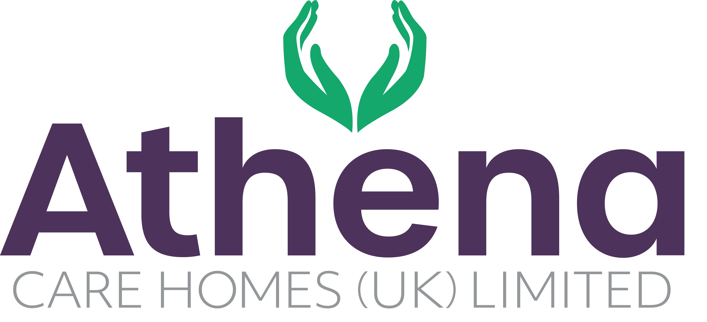

JOB DESCRIPTION

**Housekeeper**

|  |
| --- |
| **JOB SUMMARY** |

Reporting to the Head Housekeeper, the Housekeeper is responsible for ensuring a high quality of service within the home.

The Housekeeper will ensure the highest service standards of cleaning are delivered in the home.

|  |
| --- |
| **JOB SPECIFIC RESPONSIBILITIES** |

**Housekeeping Services**

* Ensure that cleaning duties are carried out in accordance to the cleaning schedule.
* Ensure team work is applied at all times to provide a clean and welcoming environment for the residents, guests and visitors.
* Maintain the highest standard of personal presentation and hygiene.
* Support the Head Housekeeper in reporting any defects or damage to furnishings within the home.
* Ensure that products being used have been specifically selected for the purpose.
* Carry out any reasonable instruction from the Head Housekeeper.
* Work with the Head Housekeeper to ensure aligned with the Athena vision and are operating from the Athena Charter.
* Complete cleaning documentation in line with company policy
* Ensure that infection control policies and universal precautions are followed at all times.
* Carry out deep cleaning in line with Athena procedures
* To actively engage with residents in conversation and meaningful occupation related to their lifestyle choices at a level and pace that values the individual and respects their dignity and communication differences.
* To respond in a timely way to residents who are distressed (calling out, calling for help, knocking or making noises that suggest the need for support) or seek assistance if you feel unable to respond appropriately.

**Health and Safety**

* Ensure all health and safety requirements are being met and attend training as required.
* Ensure regulations and compliance are met and adhered to.
* Ensure equipment and environment is safe within the home.
* Ensure the safety data sheets and risk assessments for all chemicals that are used.
* You will be required for this role to potentially liftheavy objects

|  |
| --- |
| **PERSON SPECIFICATION** |

|  |  |
| --- | --- |
|  | Essential Criteria |
| Qualifications/Education | * GCSE’s or Equivalent |
| Experience | * Experience working within a domestic environment * Health & Safety knowledge |
| **Skills/**  **Knowledge** | * Cleaning knowledge |
| Personal Qualities | * Reliable and punctual * Able to adapt to change * Willing to learn and develop * Approachable * Enthusiastic * Flexible * Patient * Positive attitude * Self-motivator * Flexible approach to working hours - able to work occasionally outside of normal hours. * Ability to promote a professional image for the company at all times * Ability to travel to other homes where needed for training / support * Able to adapt to the Athena culture |

**This job description reflects the current main organisational priorities for the position. These priorities may develop and change in consultation with the post holder in line with needs and priorities of the business.**