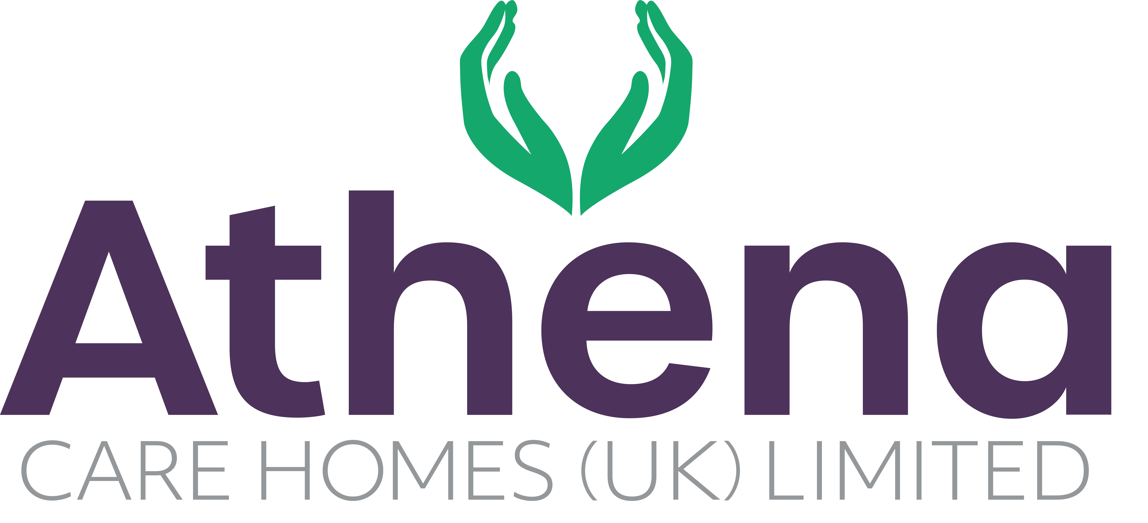

JOB DESCRIPTION

**Kitchen Assistant**

|  |
| --- |
| **JOB SUMMARY** |

Reporting to the Head Chef, the Kitchen Assistant is responsible for supporting the Head Chef to provide high quality of food service within the home.

The Kitchen Assistant will be part of the catering team ensuring the highest standards are achieved to meet the needs to the residents.

|  |
| --- |
| **JOB SPECIFIC RESPONSIBILITIES** |

**Hospitality Services**

* Support the Head Chef to ensure the catering services and residential dining experience is of the highest standard and quality.
* Support the catering team in ensuring the nutritional content of the meals provided cater for the dietary needs of all residents.
* Ensure that all regulatory and statutory requirements are met and company policies and procedures are adhered to
* Ensure that the cleaning schedules are maintained according to company policies and procedures.
* Attend all Health and Safety, food hygiene and COSSH training updates as required by the company to ensure that safe practices are adhered to at all times.
* Assist the Head Chef with meal service to the residents
* Assist the Head Chef with providing refreshments for the residents and guests to the home.
* Ensure the public areas such as dining rooms and café are clean and stocked appropriately.
* Work with the Head Chef to ensure there is sufficient crockery, cutlery and glassware in the home.
* To actively engage with residents in conversation and meaningful occupation related to their lifestyle choices at a level and pace that values the individual and respects their dignity and communication differences.
* To respond in a timely way to residents who are distressed (calling out, calling for help, knocking or making noises that suggest the need for support) or seek assistance if you feel unable to respond appropriately.

**Health and Safety**

* Ensure Health & Safety within the services team, residents and visitors meet the requirements of the Food Safety Manual and Health and Safety Manual
* Ensure regulations and compliance are met and adhered to
* Ensure equipment and environment is safe within the home
* You will be required for this role to potentially liftheavy objects

|  |
| --- |
| **PERSON SPECIFICATION** |

|  |  |
| --- | --- |
|  | Essential Criteria |
| Qualifications/Education | * NVQ level 2 in Food Hygiene (**Desirable**) |
| Experience | * Minimum of one year’s catering background * Experience working within a kitchen environment |
| **Skills/**  **Knowledge** | * Excellent written, non-verbal and verbal communication skills * Knowledge of and competence in Microsoft Office applications and windows based operating environments – i.e. Word, Excel, Outlook, Explorer |
| Personal Qualities | * Reliable and punctual * Able to adapt to change * Approachable * Confident * Willing to learn * Diplomatic * Enthusiastic * Flexible * Influencing skills * Listening skills * Negotiating skills * Patient * Positive attitude * Self-motivator * Flexible approach to working hours - able to work occasionally outside of normal hours. * Ability to promote a professional image for the company at all times * Willing and able to travel to other homes where needed for training / support * Able to adapt to the Athena culture |

**This job description reflects the current main organisational priorities for the position. These priorities may develop and change in consultation with the post holder in line with needs and priorities of the business.**