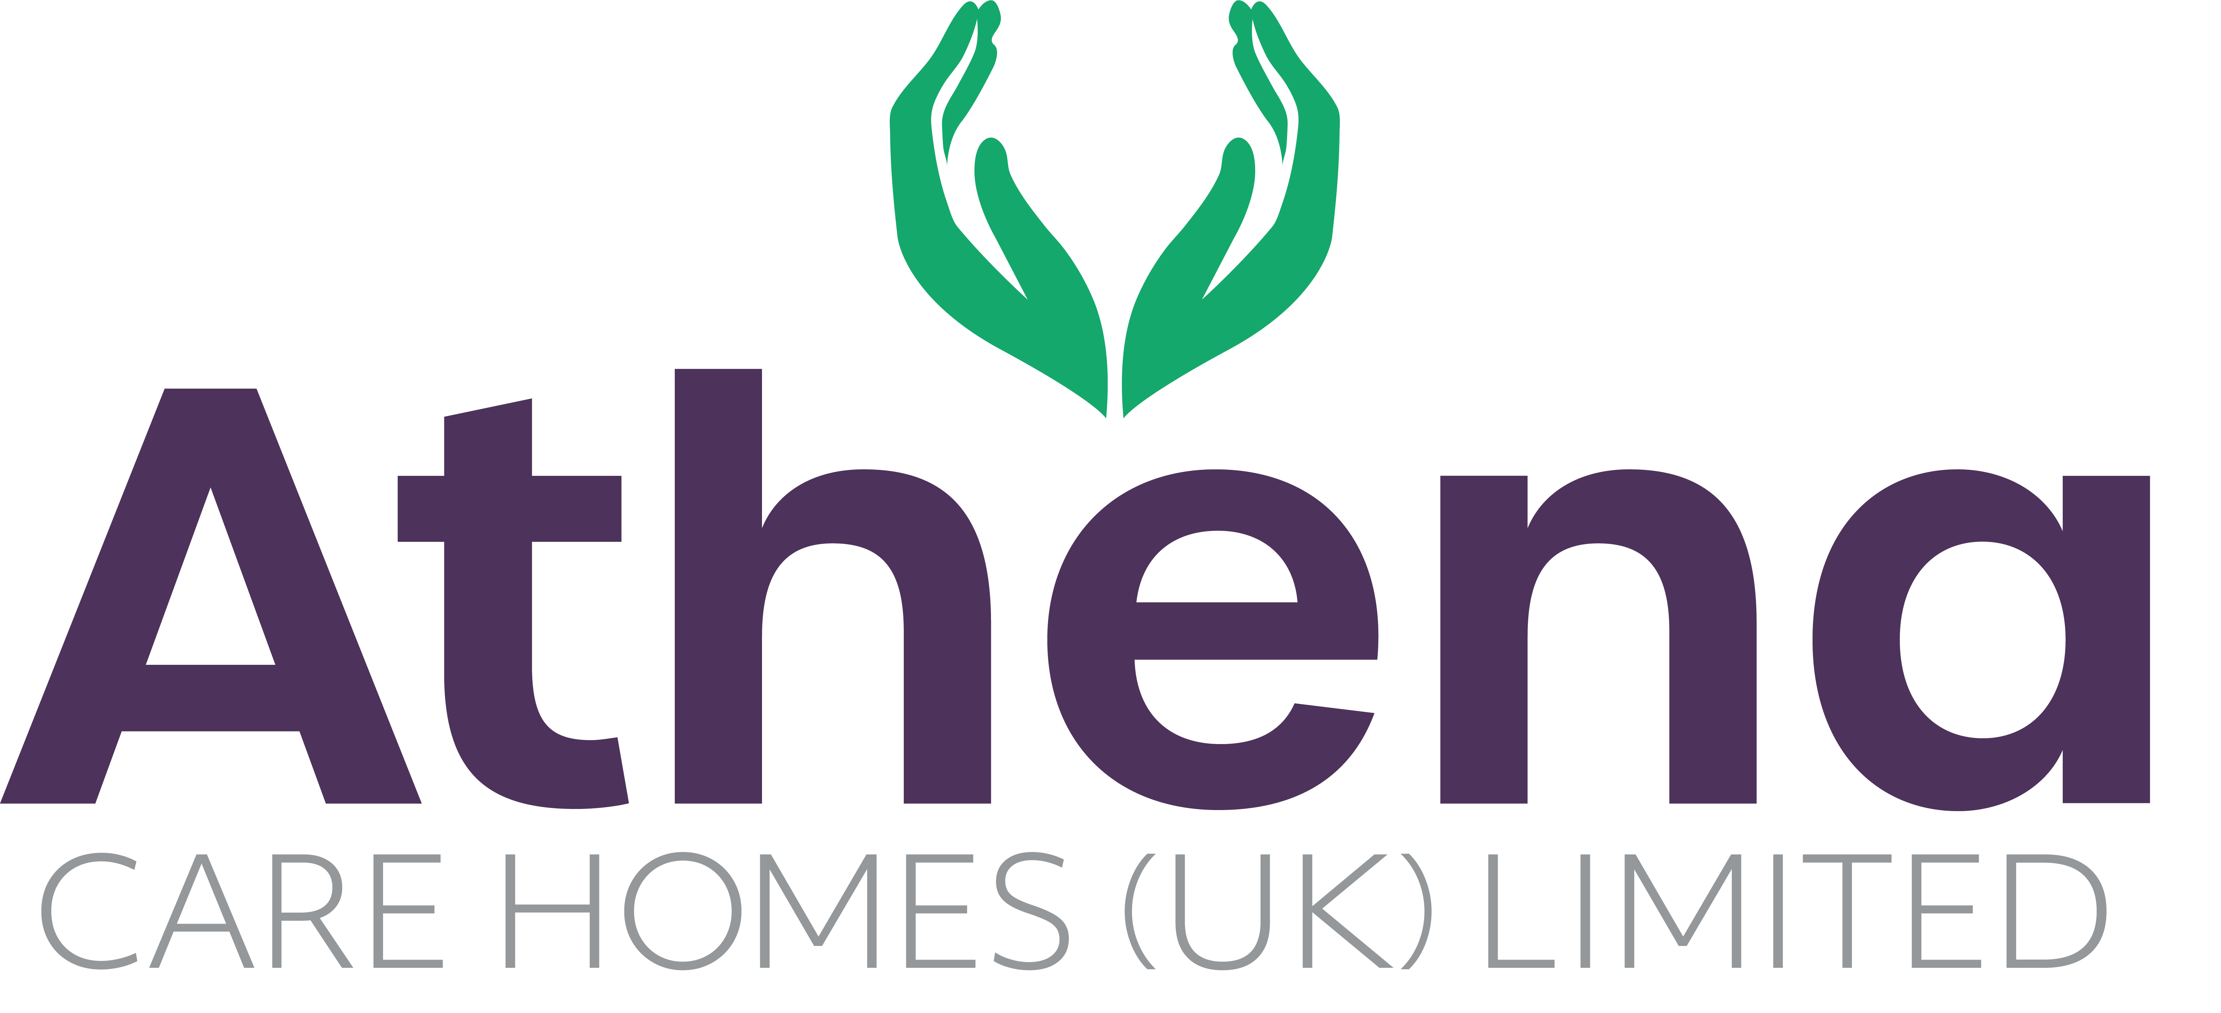

JOB DESCRIPTION

**Registered Nurse**

|  |
| --- |
| **JOB SUMMARY** |

Reporting to the Home Manager or Clinical Care Manager, the Registered Nurse (RN) is responsible for ensuring a high level of care is provided to our residents and that they comply with the NMC code of conduct and the company policies and procedures.

The RN will provide strong clinical knowledge and leadership to ensure the highest standards are achieved in the delivery of care within the home including relationship centred care, clinical care and dementia care.

|  |
| --- |
| **JOB SPECIFIC RESPONSIBILITIES** |

**Leadership and Management**

* Assist the Clinical Care Manager with responsibility for clinical care in the home.
* Assist with the recruitment and training of the clinical team; ensuring training targets are met and the teams are competent in their roles.
* Inspire the clinical team to deliver outcomes for the home.
* Ensure that all supervision, appraisal and performance management of the clinical team, supporting them to achieve their potential.
* Lead the clinical team to ensure they are aligned with the Athena vision and are operating from the Athena Charter.
* Ensure any requirements from internal and external audits are actioned within the timescales required.
* Ensure that all rotas are maintained, ensuring efficient and effective use of manpower in accordance with company policies.

**Clinical Care**

* Assist care delivery in the home, to ensure continuous assessment, planning, implementation and evaluation of resident’s care.
* Assist with ensuring care plans are regularly audited and that they are appropriate to the residents needs and reflect the care being delivered.
* Ensure medication is ordered and administered in line with company policies and procedures and the NMC guidelines.
* Proactively research current and future clinical practices to ensure Athena are leading the way with clinical care delivery.
* Ensure that all regulatory and statutory requirements are met and company policies and procedures are adhered to.
* Develop and promote good communication with residents, relatives and team members.
* Ensure that the Clinical Care Manager is made aware of any clinical issues within the home.
* Ensure that all care given is within the NMC codes of practice.
* Ensure confidentiality in respect of residents.
* To assist in the development and implementation of the activities programme.
* Liaise with GP’s and other professionals to ensure outstanding care for the residents is maintained.
* To assist with the delivery of food and drink to the residents.
* To continually improve and update personal development in accordance with the requirements of PREP.
* Ensure all complains are dealt with appropriately in line with the company policies and procedures.
* To actively engage with residents in conversation and meaningful occupation related to their lifestyle choices at a level and pace that values the individual and respects their dignity and communication differences.
* To respond in a timely way to residents who are distressed (calling out, calling for help, knocking or making noises that suggest the need for support) or seek assistance if you feel unable to respond appropriately.

**Health and Safety**

* Ensure Home Manager is informed of any incidents in the absence of the Clinical Care Manager.
* Ensure storage of medications are in line with company policies and procedures.
* Ensure risk assessments are completed within the home and safe working practices are being followed.
* Ensure equipment and environment is safe within the home.

|  |
| --- |
| **PERSON SPECIFICATION** |

|  |  |
| --- | --- |
|  | Essential Criteria |
| Qualifications/Education | * NQF level 6 or equivalent RN/RGN Qualified or RMN or RNLD * Dementia Qualification (for homes with people living with dementia) (**Desirable**) |
| Experience | * Proven track record leading, empowering, supporting and motivating a clinical team * Experience delivering high quality relationship centred care (**Desirable**) |
| **Skills/**  **Knowledge** | * Strong leadership and management skills * Excellent written, non-verbal and verbal communication skills * Dementia Knowledge (for homes with people living with dementia) |
| Personal Qualities | * Reliable and punctual * Able to adapt to change * Willing to learn and develop * Approachable * Confident * Diplomatic * Enthusiastic * Flexible * Influencing skills * Listening skills * Negotiating skills * Patient * Positive attitude * Self-motivator * Flexible approach to working hours - able to work occasional outside of normal hours. * Ability to promote a professional image for the company at all times * Willing and able to travel to other homes where needed for training / support * Able to adapt to the Athena culture |

**This job description reflects the current main organisational priorities for the position. These priorities may develop and change in consultation with the post holder in line with needs and priorities of the business.**