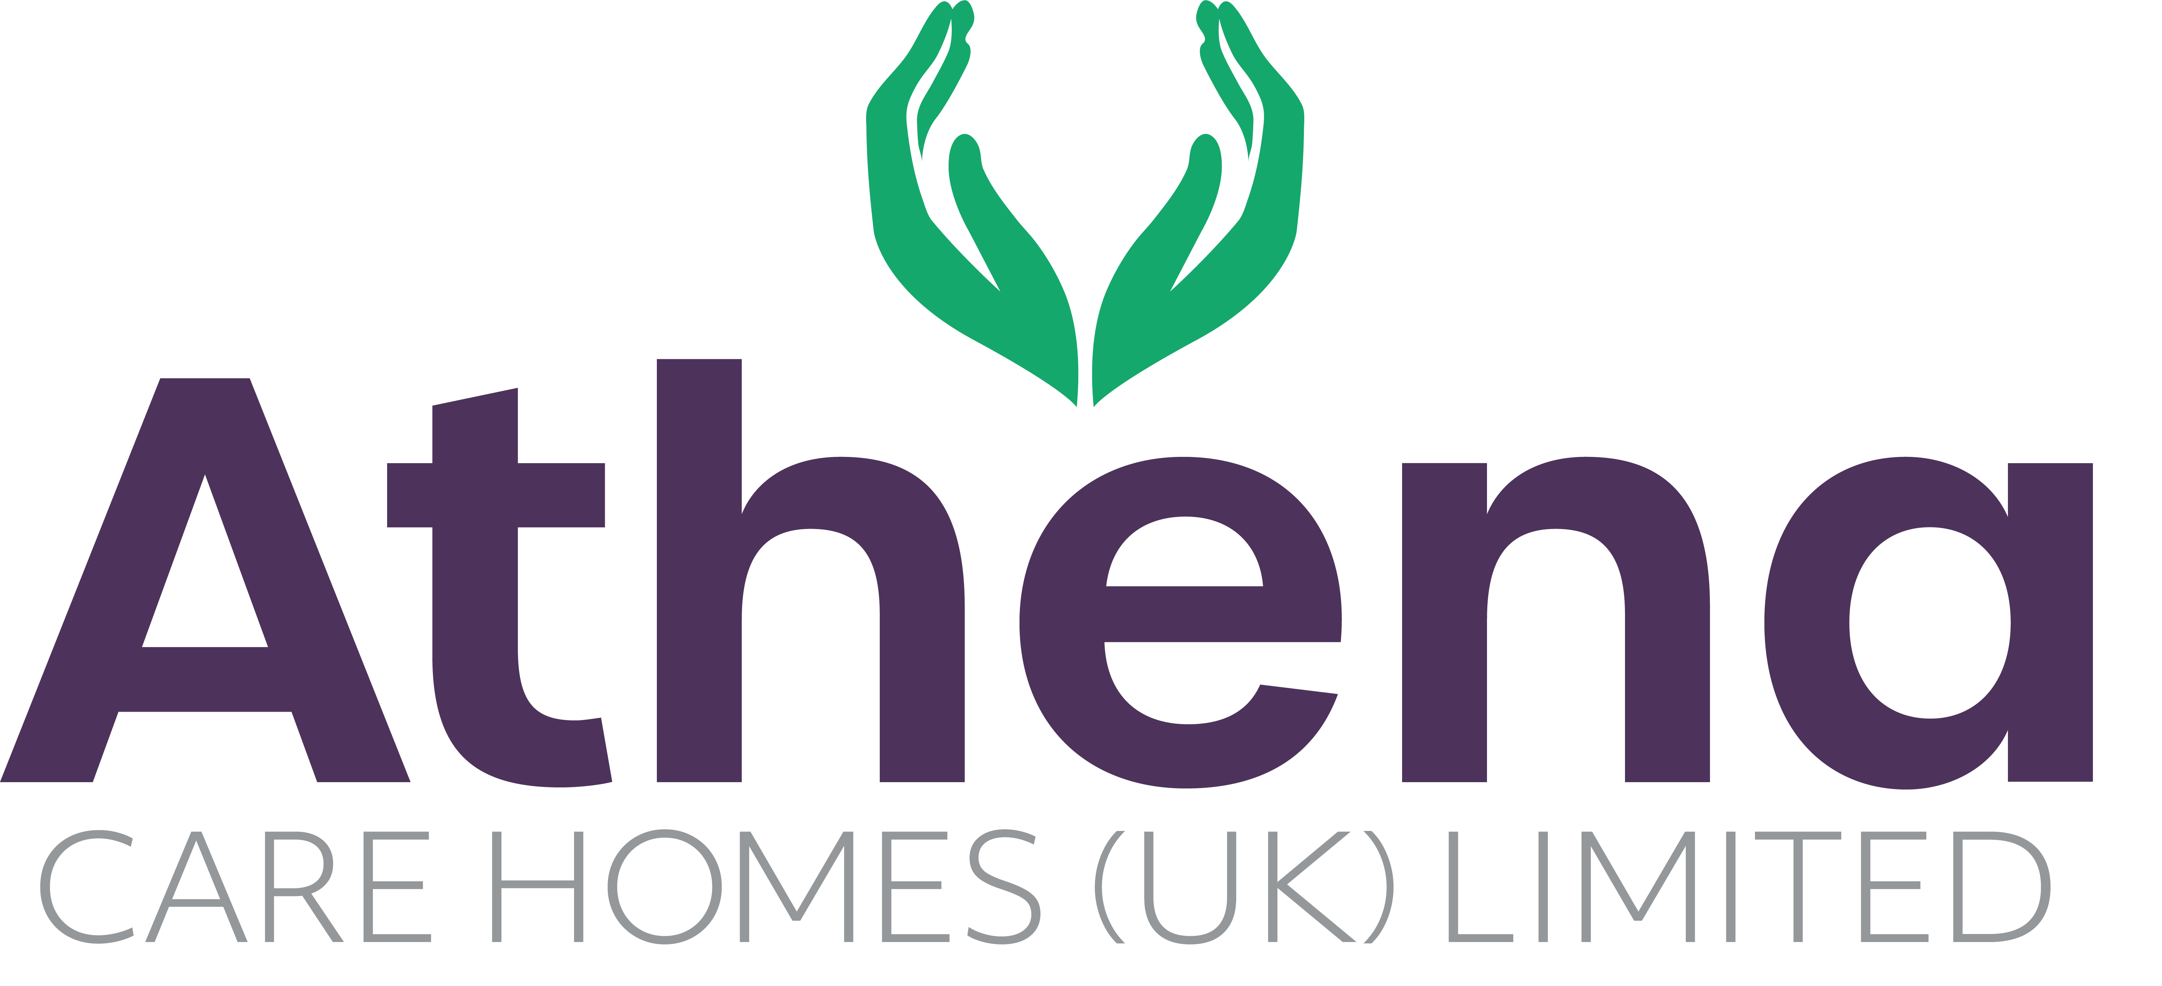

JOB DESCRIPTION

**Multi-Skilled Maintenance Operative**

|  |
| --- |
| JOB SUMMARY |

Multi-Skilled Maintenance Operative will support the ongoing repair and upkeep of our care home facilities. This hands-on role involves a wide range of maintenance and repair tasks, including plumbing, plastering, joinery, painting, bricklaying, and roofing.

In addition to day-to-day maintenance, the role will also include larger-scale projects such as kitchen installations and fitting fire-rated doors in line with current regulatory standards. The Multi-Skilled Maintenance Operative will deliver high-quality work that ensures a safe, comfortable, and well-maintained environment for residents and staff alike.

|  |
| --- |
| JOB SPECIFIC RESPONSIBILITIES |

* Complete multi-functional repair tasks to a high standard
* Communicating with residents and home manager before, during and after repairs have been carried out
* Works in a manner which complies with safety regulation and Athena procedures
* Ensure that materials, plant, and equipment are used for their intended purpose

and are stored and maintained in accordance with manufacturers guidelines

* Carry out weekly/ monthly/ quarterly checks as required by the regulatory body
* Investigate and respond to any complaint received in line with Athenas policy and procedures
* Respond to all residents/ home managers’ queries, either resolving immediately or agreeing a plan of action and monitoring action to completion
* Must have a good understanding of building regulations and Health & Safety regulations
* Provide a high quality, committed and rounded service for Resolve Solutions
* Assist the other teams within the home to provide a clean and welcoming environment.
* Oversee external works and contractors and manage the snagging works

**Health and Safety**

* Overall responsibility for carrying our weekly tests of the emergency systems within the home.
* Ensure regulations and compliance are met and adhered to.
* Overall responsibility to ensure all checks are up to date and servicing is completed for equipment within the home
* Ensure equipment and environment is safe within the home.

|  |
| --- |
| PERSON SPECIFICATION |

|  |  |
| --- | --- |
|  | Essential Criteria |
| Qualifications/Education | * Management Qualification (Desirable) * Recognised apprenticeship or equivalent and/or NVQ level 3 or equivalent |
| Experience | * Minimum of three years’ experience working in similar role in a healthcare environment * Previous experience working at height, asbestos awareness, MEWPs/ PASMA * Full clean UK driving licence |
| **Skills/**  **Knowledge** | * Understanding of repairs and maintenance in domestic properties * Health & Safety awareness * Knowledge of joinery, plumbing and other trades * Ability to prepare and explain numerical data * Ability to generate reports using relevant software and devices * Strong IT skills and confident using Microsoft Office packages such as Outlook, Word, Excel and PowerPoint |
| Personal Qualities | * Reliable and punctual * Able to adapt to change * Approachable * Confident * Diplomatic * Enthusiastic * Flexible * Good influencing skills * Good listening skills * Good negotiating skills * Patient * Positive attitude * Self-motivator * Flexible approach to working hours - able to work occasionally outside of normal hours. * Ability to promote a professional image for the company at all times * Ability to travel to other homes where needed for training / support * Able to adapt to the Athena culture |

**This job description reflects the current main organizational priorities for the position. These priorities may develop and change in consultation with the post holder in line with needs and priorities of the business.**