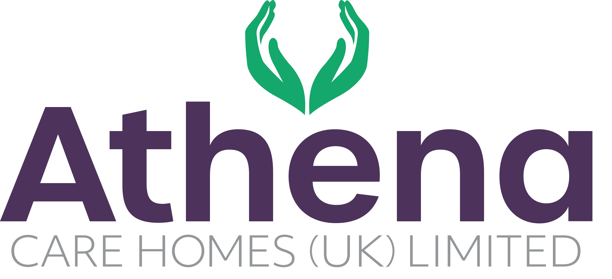

JOB DESCRIPTION

**Chef**

|  |
| --- |
| **JOB SUMMARY** |

As a key member of our kitchen team, the Chef plays an important role in delivering high-quality, nutritious meals that support the wellbeing of our residents. Working under the guidance of the Head Chef, you’ll be responsible for preparing and serving food to the highest standard, ensuring every meal is both delicious and thoughtfully presented.

You’ll work closely with colleagues across the home to maintain excellent service, creating a positive dining experience that reflects our commitment to care, comfort, and community.

|  |
| --- |
| **JOB SPECIFIC RESPONSIBILITIES** |

**Leadership and Management**

* Assist the Head Chef with all regulatory and statutory requirements are met and company policies and procedures are adhered to.
* Ensure reports relating to catering are completed accurately and on time.
* Ensure that food levels are correct and in line with the budgets to ensure all expenditure targets are met.
* Ensure any requirements from internal and external audits are actioned within the timescales required.
* Support the Head of Culinary & Hospitality and the Home Manager with stock control of crockery, cutlery and glassware.
* Ensure you are aligned with the Athena vision and are operating from the Athena Charter.

**Hospitality Services**

* Work with the Head Chef to ensure the catering services and residential dining experience is of the highest standard and quality.
* Promote choice and dignity to the residents of the home with the services we provide
* Ensure the nutritional content of the meals provided cater for the dietary needs of all residents.
* Work with the Head Chef to ensure the audits for the kitchen are completed and fed back to the team
* Liaise with residents to ensure they are happy with the food and beverages being delivered within the home
* Work closely with the Head of Culinary & Hospitality and the Home Manager to ensure quality standards are met
* Ensure that requirements of the Food Safety Manual, Health and Safety Manual and Meal policies requirements are met.
* To actively engage with residents in conversation and meaningful occupation related to their lifestyle choices at a level and pace that values the individual and respects their dignity and communication differences.
* To respond in a timely way to residents who are distressed (calling out, calling for help, knocking or making noises that suggest the need for support) or seek assistance if you feel unable to respond appropriately.

**Health and Safety**

* Be accountable for Health & Safety within the kitchen.
* Ensure regulations and compliance are met and adhered to.
* Ensure cleanliness of kitchen and hygiene standards is achieved and maintained.
* Ensure equipment and environment is safe within the home.
* You will be required for this role to potentially liftheavy objects

|  |
| --- |
| **PERSON SPECIFICATION** |

|  |  |
| --- | --- |
|  | Essential Criteria |
| Qualifications/Education | * NVQ level 2 in Food Hygiene |
| Experience | * Minimum of two years catering background * Experience working within a kitchen environment * Health & Safety knowledge in a busy working environment * Proven track record in a care home environment delivering quality services (Desirable) |
| **Skills/**  **Knowledge** | * Strong leadership and management skills * Excellent written, non-verbal and verbal communication skills * Knowledge of and competence in Microsoft Office applications and Windows based operating environments – Excel, Word, Outlook, Explorer etc |
| Personal Qualities | * Reliable and punctual * Able to adapt to change * Approachable * Confident * Diplomatic * Enthusiastic * Flexible * Influencing skills * Listening skills * Negotiating skills * Patient * Positive attitude * Self-motivator * Flexible approach to working hours - able to work occasionally outside of normal hours. * Ability to promote a professional image for the company at all times * Ability to travel to other homes where needed for training / support * Able to adapt to the Athena culture |

**This job description reflects the current main organisational priorities for the position. These priorities may develop and change in consultation with the post holder in line with needs and priorities of the business.**