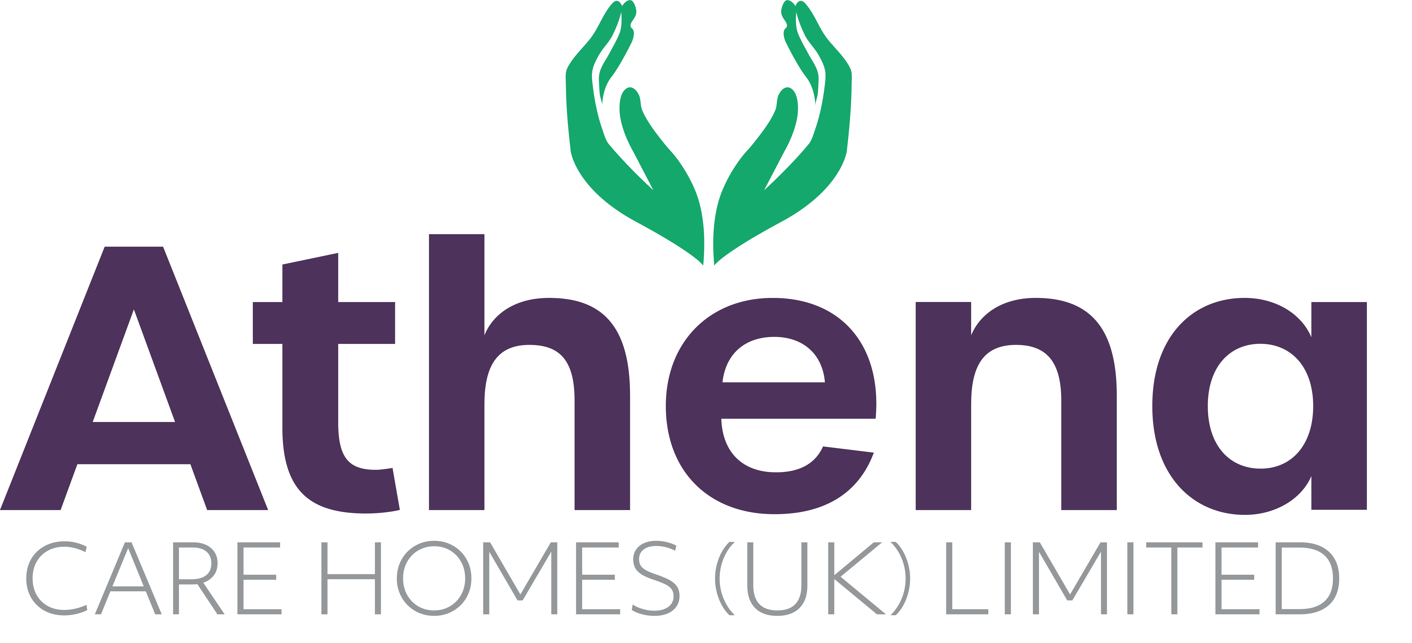

JOB DESCRIPTION

|  |
| --- |
| JOB DETAILS |

JOB TITLE: Regional Trainer

HOURS: 37.5 hours per week

REPORTING TO: Learning and Development Manager

BASE: Regional

|  |
| --- |
| JOB SUMMARY |

The Regional Trainer will play a key role in the delivery of high-quality, engaging learning initiatives, ensuring all staff are competent, confident and culturally aligned with Athena’s values.

Working with the Learning & Development Manager, this role is instrumental in moving our learning & development function from compliance-driven to impact-focused, by supporting growth and enabling our managers to identify and develop talent in their teams.

|  |
| --- |
| JOB SPECIFIC RESPONSIBILITIES |

* Deliver high-impact, engaging, interactive training sessions using a variety of formats, including classroom, virtual, blended learning and focused on-the-job coaching.
* Facilitate statutory and mandatory training including (but not limited to): Basic Life Support, Safer People Handling, Infection Control, MCA & DoLS, Fire Safety, Medication Awareness, Dementia Care, and Care Certificate standards.
* Support and deliver the induction of new staff, ensuring timely completion of required training and competence sign-off.
* Develop, adapt and continually improve training materials, presentations, and resources in line with Athena’s brand, best practice and sector requirements.
* Support the rollout of new learning initiatives, including eLearning and blended learning.
* Maintain accurate and auditable records using the Learning Management System, LMS, to monitor and report compliance across the group, in line with regulatory and internal requirements.
* Work proactively with Home Managers to identify training gaps and development needs that directly impact CQC inspection outcomes.
* Stay up to date with sector developments, CQC requirements, and best practice in adult social care training.
* Act as a Cultural Champion, coaching managers and teams to embed Athena’s values in daily interactions.

|  |
| --- |
| PERSON SPECIFICATION |

|  |  |
| --- | --- |
|  | Essential Criteria |
| Qualifications/Education | * Level 3 Award in Education & Training (AET) or equivalent teaching qualification. * Evidence of continued professional development. |
| Experience | * Demonstrable experience of working within a highly regulated industry where adherence to statutory, mandatory, and legislative requirements in paramount. * Proven experience delivering high-quality, high-volume training in a multi-site or regional environment. * Experience coaching and supporting staff in practice. * Experience developing and adapting training materials. * Experience of delivering training in a care home or healthcare setting is desirable. * Strong knowledge of CQC standards, Skills for Care frameworks, and current sector best practice is desirable – to be developed quickly if not held. |
| **Skills/**  **Knowledge** | * Excellent presentation and facilitation skills with the ability to manage diverse groups. * Strong knowledge of adult learning principles and blended learning methodologies. * Proficient in Microsoft Office, Teams, and eLearning platforms. * Strong knowledge of compliance methodologies and audit requirements in a regulated setting. * Strong organisational and time management skills, able to prioritise competing regional demands. |
| Personal Qualities | * Professional, approachable, and engaging. * Confident communicator with the ability to motivate and inspire others. * Flexible and adaptable to meet the needs of the business. * Willingness to travel across the region and work flexibly. * Passionate about developing others and improving care standards. |

**This job description reflects the current main organisational priorities for the position. These priorities may develop and change in consultation with the post holder in line with needs and priorities of the business.**