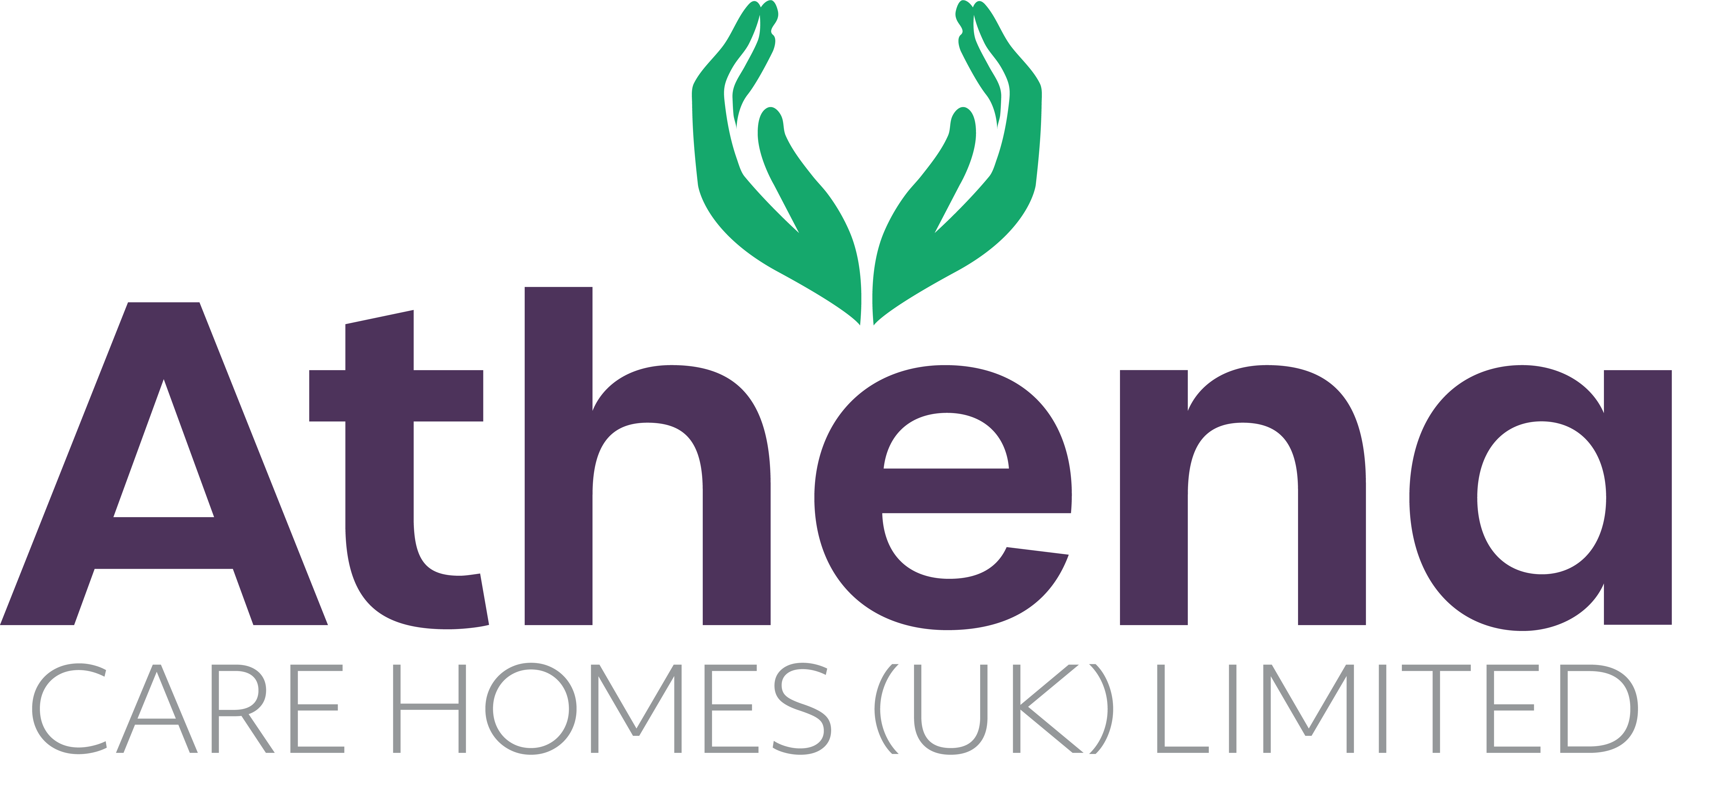

JOB DESCRIPTION
Multi-Skilled Maintenance Assistant

JOB SUMMARY

To support the safe and efficient operation of Athena Care Homes by carrying out planned, reactive, and preventative maintenance tasks across a range of trades (carpentry, plumbing, electrical, decorating, and general repairs). The role ensures that the environment remains safe, compliant, and welcoming for residents, staff, and visitors.

JOB SPECIFIC RESPONSIBILITIES

- Carry out day-to-day maintenance requests promptly, ensuring minimal disruption to residents.
- Undertake planned preventative maintenance (PPM) tasks, including checks on lighting, heating, water systems, fire safety equipment, and emergency call systems.
- Assist with small plumbing, joinery, tiling, plastering, and painting/decorating tasks.
- Support electrical maintenance activities (changing lamps, socket repairs, minor fault finding) within competency.
- Ensure external areas, gardens, and car parks are maintained to a safe and tidy standard.
- Monitor and report on compliance checks including legionella flushing, fire alarm testing, emergency lighting, and portable appliance testing.
- Work in accordance with Health & Safety regulations, risk assessments, and company policies.
- Ensure correct use of PPE and safe working practices at all times.
- Liaise with contractors and suppliers when required, escorting them on site and ensuring permits-to-work are followed.
- Maintain accurate records of works carried out, materials used, and ensure timely reporting to the Head of Estates / Home Manager.
- Support emergency response (e.g., power failures, leaks, fire alarm activations) ensuring swift action and escalation where necessary.

PERSON SPECIFICATION

 | Essential Criteria
Qualifications/Education | - Trade qualification (desirable but not essential).  - Health & Safety awareness training?  - Willingness to undertake further training relevant to the role (e.g., PAT testing, legionella awareness, working at height).
Experience | - Proven experience in a multiskilled maintenance role (care, hospitality, commercial, or similar environment).
Skills/  Knowledge | - Basic knowledge of plumbing, carpentry, and electrics.  - Strong problem-solving and fault-finding skills.  - Ability to work flexibly and independently, prioritising tasks effectively.  - Good communication skills with staff, residents, and contractors.  - Understanding of compliance requirements including fire safety, legionella, COSHH, and safe systems of work.
Personal Qualities | - Reliable and punctual  - Able to adapt to change  - Approachable  - Confident  - Diplomatic  - Enthusiastic  - Flexible  - Good influencing skills  - Good listening skills  - Good negotiating skills  - Patient  - Positive attitude  - Self-motivator  - Flexible approach to working hours - able to work occasionally outside of normal hours.  - Ability to promote a professional image for the company at all times  - Ability to travel to other homes where needed for training / support  - Able to adapt to the Athena culture

This job description reflects the current main organizational priorities for the position. These priorities may develop and change in consultation with the post holder in line with needs and priorities of the business.

