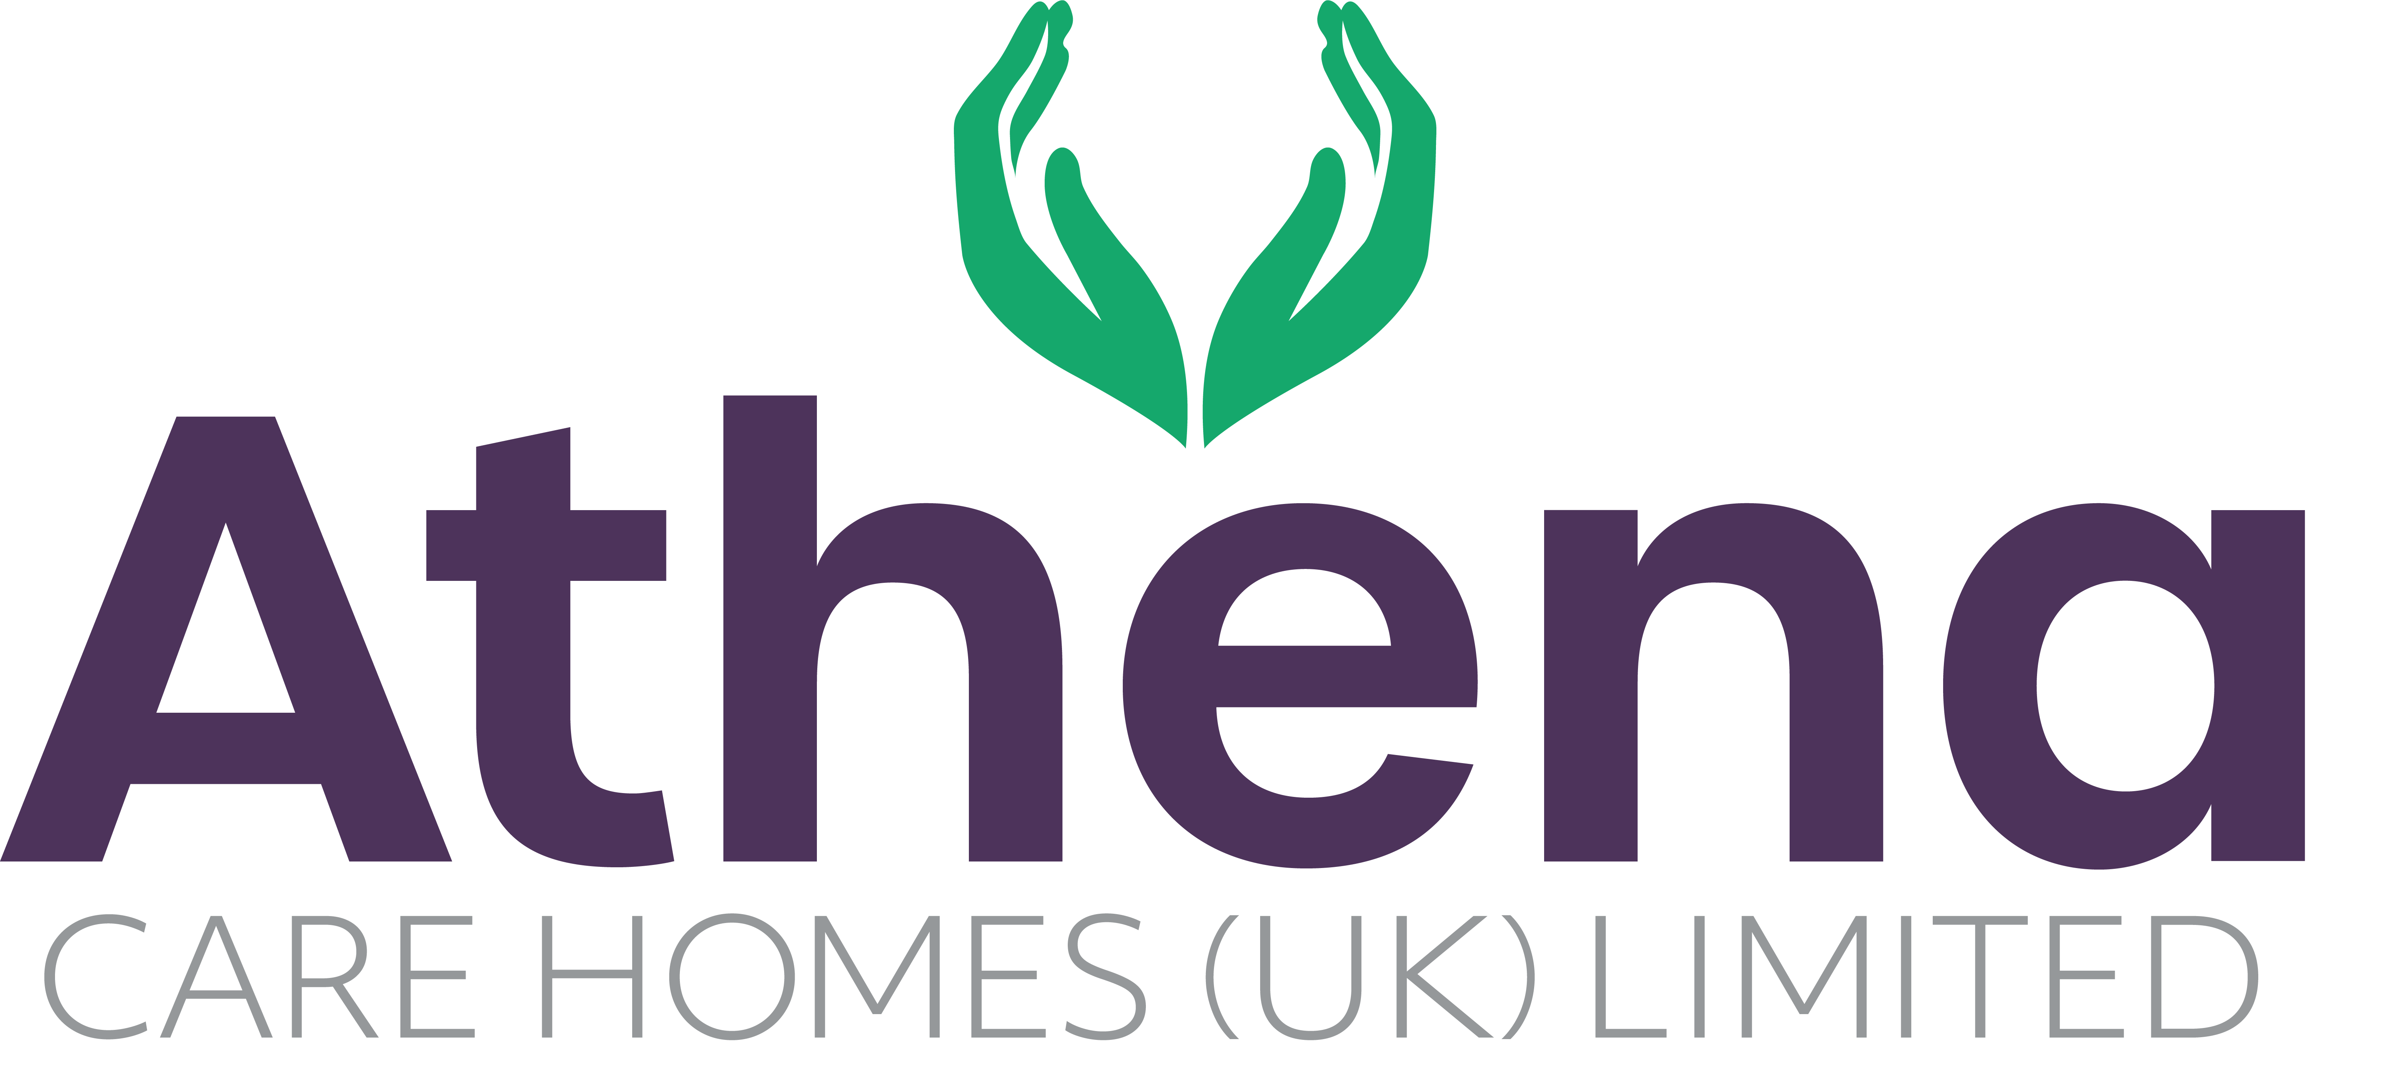

JOB DESCRIPTION

JOB DETAILS

JOB TITLE: Head of Culinary & Hospitality

HOURS: 37.5 hours per week

REPORTING TO: CEO

BASE: Regional

JOB SUMMARY

The Head of Culinary & Hospitality plays a vital leadership role in ensuring that every resident experiences meals, refreshments and hospitality that are nourishing, dignified and genuinely enjoyable.

This role exists to raise and sustain exceptional standards of food and hospitality across all Athena homes. Working closely with our Chefs, Kitchen Teams and Customer Care colleagues, you will inspire great culinary practice, ensure excellent regulatory compliance, and help create warm, welcoming environments where residents, families and visitors feel truly cared for.

JOB SPECIFIC RESPONSIBILITIES

Culinary Leadership
- Lead the development of Athena’s food offering, ensuring consistently high standards across all homes.
- Work alongside Head Chefs and kitchen teams to inspire creativity, quality and pride in what we serve.
- Support menu development that is seasonal, nutritious, varied and aligned to resident preferences and needs.
- Embed best practice for specialist diets, including dementia-friendly dining and IDDSI-compliant meals.
- Ensure all homes achieve and maintain 5-star EHO ratings and meet all food safety and hygiene requirements.

People Development & Professional Practice
- Work closely with the Learning & Development team to create meaningful development pathways for kitchen and hospitality staff, helping them grow in confidence, skill and professionalism.
- Support recruitment of Head Chefs and contribute to building strong, values-led kitchen teams.
- Provide oversight and guidance on kitchen rotas to ensure safe, effective and well-balanced staffing.

Procurement & Supplier Relationships
- Work collaboratively with procurement and suppliers to source high-quality, cost-effective and sustainable ingredients.
- Ensure products meet Athena’s standards for nutrition, safety, consistency and resident enjoyment.

Hospitality & Resident Experience
- Partner closely with the Customer Care and Service Delivery Lead to ensure hospitality in every home reflects Athena’s values of warmth, dignity and kindness.
- Support the delivery of meaningful everyday hospitality, including experiences such as daily afternoon tea, celebrations and special events.
- Work with homes to enhance presentation of dining areas, showrooms and shared spaces so they are always welcoming, attractive and resident-focused.

Collaboration
- Be an active member of Athena’s wider Customer Care and Experience team, working alongside the Head of Lifestyles & Community Engagement, Customer Care & Service Delivery Lead and the Customer Relationship Manager.
- Collaborate with activities and community engagement teams to ensure food and hospitality enhance social connection, wellbeing and community life in our homes.

Governance, Policy & Quality
- Review, develop and write policies related to food, dining and safety, including areas such as choking risk and safe swallowing.
- Ensure strong compliance with regulatory, clinical and quality standards.
- Use audits, feedback and quality data to drive continuous improvement across all catering and hospitality services.

PERSON SPECIFICATION

 | Essential Criteria
Qualifications/Education | - A recognised professional qualification in catering, culinary arts, hospitality management or a related field, or equivalent experience.  - Food safety and hygiene qualification (Level 3 or above, or willingness to achieve).  - Evidence of ongoing professional development within food, hospitality or care environments.
Experience | - Significant experience in a senior culinary, catering or hospitality leadership role, ideally within health, social care, or a regulated environment.  - Experience of leading quality improvement across multiple sites or teams.  - Proven track record of achieving and maintaining high food safety standards, including EHO 5-star ratings.  - Experience of supporting, coaching and developing chefs and kitchen teams.  - Experience of delivering or overseeing hospitality services that enhance customer and resident experience.
Skills/  Knowledge | - In-depth knowledge of food safety legislation, HACCP, allergens, and environmental health requirements.  - Strong understanding of nutrition, texture-modified diets and IDDSI frameworks.  - Knowledge of dementia-friendly dining and how food, environment and presentation support wellbeing.  - Ability to design, implement and review policies, procedures and standards.  - Strong coaching and influencing skills, with the ability to lead without direct line management.  - Ability to analyse quality, audit and feedback data to drive continuous improvement.  - Strong organisational and communication skills, able to work effectively with clinical, care, lifestyle and customer care teams.
Personal Qualities | - A genuine passion for food, hospitality and improving people’s everyday lives.  - Warm, approachable and respectful, with a strong commitment to dignity, kindness and person-centred care.  - Inspiring and motivational, able to bring out the best in others.  - Collaborative and team-oriented, comfortable working across disciplines.  - Calm, resilient and solutions-focused in a fast-moving environment.  - High standards, attention to detail and pride in delivering excellence.  - Values-led, with a strong alignment to Athena’s culture and purpose.

This job description reflects the current main organizational priorities for the position. These priorities may develop and change in consultation with the post holder in line with needs and priorities of the business.

