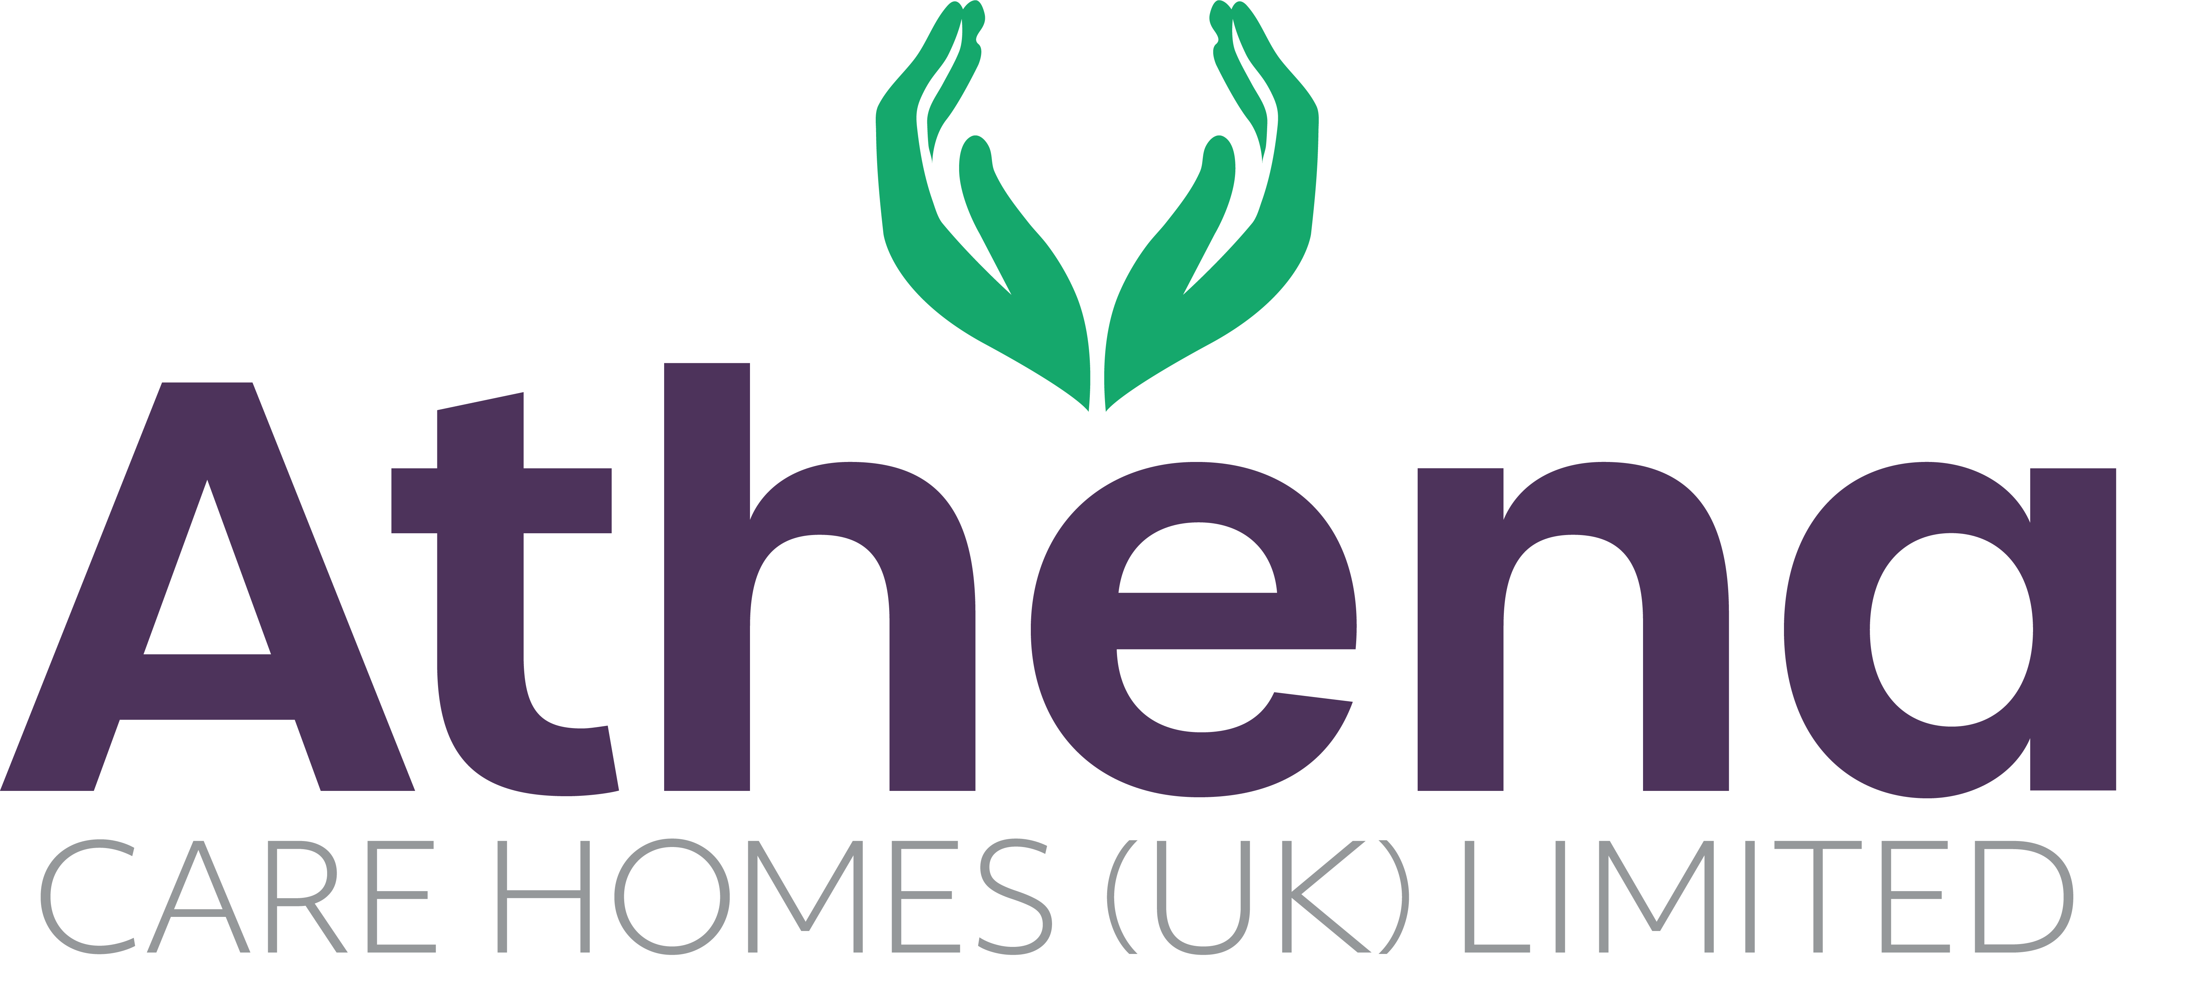

JOB DESCRIPTION

JOB DETAILS

JOB TITLE: Quality Auditor

HOURS: 37.5 hours per week

REPORTING TO: CEO

BASE: Regional

JOB SUMMARY

The Quality Auditor will lead the delivery of Athena Care Homes' internal audit programme, providing assurance that homes operate in compliance with all relevant regulations, legislation, policies and quality standards.

The post holder will undertake comprehensive six-monthly whole-home audits, targeted thematic audits and ad hoc investigations to assess compliance across key operational areas. They will produce detailed reports, identify risks and areas for improvement, and monitor action plans to completion.

The role will support Athena's governance framework by ensuring effective oversight of compliance relating to regulatory requirements including CQC, Environmental Health, Health & Safety, PAMMS and other relevant legislative and contractual standards.

JOB SPECIFIC RESPONSIBILITIES

Internal Audit & Compliance Assurance
- Develop and deliver a robust internal audit programme across all Athena Care Homes.
- Conduct comprehensive six-monthly whole-home compliance audits against organisational standards and regulatory requirements.
- Undertake ad hoc, focused and thematic audits in response to incidents, trends, concerns, complaints or identified risks.
- Review systems, records, processes and practices to assess compliance and effectiveness.
- Evaluate compliance against:
  - Care Quality Commission (CQC) regulations and standards
  - PAMMS requirements
  - Environmental Health requirements
  - Health & Safety legislation
  - Safeguarding requirements
  - Medicines management standards
  - Data protection requirements
  - Employment and workforce compliance obligations
  - Athena Care Homes policies and procedures
- Identify areas of non-compliance, risk and improvement opportunities.

Reporting & Action Planning
- Produce detailed audit reports outlining findings, areas of good practice, risks and recommendations.
- Develop and agree action plans with Home Managers and operational leaders.
- Monitor progress against action plans and verify completion of corrective actions.
- Escalate significant compliance concerns and unresolved risks through appropriate governance channels.
- Maintain accurate records of audit findings, evidence and outcomes.

Governance & Risk Management
- Support the organisation's governance and assurance framework by providing objective assessments of compliance performance.
- Analyse audit findings and compliance data to identify emerging trends and organisational risks.
- Contribute to organisational risk registers and governance reporting.
- Provide regular assurance reports to senior leadership teams.
- Support preparation for regulatory inspections and external audits.

Systems & Compliance Monitoring
- Utilise electronic governance, compliance and quality systems, including RADAR and other organisational platforms, to record findings, monitor actions and track performance.
- Review compliance data and key performance indicators to identify areas requiring further investigation.
- Ensure accurate and timely reporting of audit outcomes and compliance status.

Continuous Improvement
- Promote a culture of accountability, compliance and continuous improvement across the organisation.
- Share learning and best practice arising from audit activity.
- Support managers in understanding compliance requirements and implementing sustainable improvements.
- Keep up to date with changes in legislation, regulation and sector best practice, ensuring these are reflected within audit processes.

PERSON SPECIFICATION

 | Essential Criteria
Qualifications/Education | - Educated to Level 5 or above in Health and Social Care, Leadership and Management, Business Management, Quality Assurance or a related discipline.  - Evidence of continuing professional development relevant to compliance, governance or adult social care.  - Internal Auditor, Quality Assurance or Governance qualification would be desirable.
Experience | - Experience within adult social care, compliance, governance, quality assurance or auditing roles.  - Experience conducting audits and producing detailed compliance reports.  - Experience developing and monitoring corrective action plans.  - Experience working with regulatory frameworks and compliance standards within the care sector.  - Experience identifying risks and implementing assurance processes across multiple services.  - Experience auditing against PAMMS frameworks.  - Experience supporting services through regulatory inspections and external audits.  - Experience working across multiple care homes or services.
Skills/  Knowledge | - Strong knowledge of adult social care regulations and compliance requirements.  - Understanding of CQC regulations, PAMMS, Health & Safety and Environmental Health standards.  - Strong auditing, investigative and analytical skills.  - Ability to assess compliance against policies, procedures and regulatory standards.  - Excellent report-writing and documentation skills.  - Strong organisational and time management skills.  - Ability to challenge constructively and influence positive change.  - Proficient in Microsoft Office and electronic governance systems.  - Experience using compliance and quality management systems, including RADAR or similar platforms.  - Knowledge of governance and risk management frameworks.  - Experience analysing compliance data and performance metrics.  - Ability to interpret regulatory guidance and communicate requirements effectively across the organisation.
Personal Qualities | - High levels of integrity, objectivity and professionalism.  - Strong attention to detail and commitment to accuracy.  - Ability to work independently and manage multiple priorities.  - Confident communicator with strong interpersonal skills.  - Resilient and able to maintain professional judgement in challenging situations.  - Collaborative approach with the ability to build positive working relationships.  - Committed to maintaining high standards of compliance and resident safety.  - Flexible and adaptable to changing regulatory and organisational requirements.

This job description reflects the current main organizational priorities for the position. These priorities may develop and change in consultation with the post holder in line with needs and priorities of the business.

